Installing and Configuring Raspberry Pi System

# 

1. Preface 2

2. Introduction of Raspberry Pi 2

3. Installing an Operating System 8

3.1Component List 8

3.2 Optional Components 10

3.3 Raspberry Pi OS 12

3.4Write System to Micro SD Card 16

3.5Enable ssh and configure WiFi 19

3.6 Insert SD card 22

4. Getting Started with Raspberry Pi 23

4.1 Monitor desktop 23

4.2 Remote desktop & VNC 26

5. Starting Preparation 37

5.1 Linux Command 37

5.2 Shortcut Key 40

5.3 Install WiringPi 41

5.4 Obtain the Project Code 43

6. Python2 & Python3 44

# 1. Preface

Raspberry Pi is a low cost, **credit card sized computer** that plugs into a computer monitor or TV, and uses a standard keyboard and mouse. It is an incredibly capable little device that enables people of all ages to explore computing, and to learn how to program in a variety of computer languages like Scratch and Python. It is capable of doing everything you would expect from a desktop computer, such as browsing the internet, playing high-definition video content, creating spreadsheets, performing word-processing, and playing video games. For more information, you can refer to Raspberry Pi official [website.](https://www.raspberrypi.org/) For clarification, this tutorial will also reference Raspberry Pi as RPi, RPI and RasPi.

Additionally, if you encounter any issues or have questions about this tutorial , you can always contact us for free technical support at:cokoino@outlook.com

# 2.Introduction of Raspberry Pi

So far, at this writing, Raspberry Pi has advanced to its fifth generation product offering. Version changes are accompanied by increases in upgrades in hardware and capabilities.

The A type and B type versions of the first generation products have been discontinued due to various reasons. What is most important is that other popular and currently available versions are consistent in the order and number of pins and their assigned designation of function, making compatibility of peripheral devices greatly enhanced between versions.

Below are the raspberry pi pictures and model pictures . They have 40 pins.

|  |  |
| --- | --- |
| Actual image of Raspberry Pi 5 |  |
|  |  |
| Actual image of Raspberry Pi 4 Model B： | CAD image of Raspberry Pi 4 Model B： |
|  |  |
| Actual image of Raspberry Pi 3 Model B+： | CAD image of Raspberry Pi 3 Model B+： |
|  |  |
| Actual image of Raspberry Pi 3 Model B: | CAD image of Raspberry Pi 3 Model B: |
|  |  |
| Actual image of Raspberry Pi 2 Model B: | CAD image of Raspberry Pi 2 Model B: |
|  |  |
| Actual image of Raspberry Pi 1 Model B+: | CAD image of Raspberry Pi 1 Model B+: |
|  |  |
| Actual image of Raspberry Pi 3 Model A+: | CAD image of Raspberry Pi 3 Model A+: |
|  |  |
| Actual image of Raspberry Pi 1 Model A+: | CAD image of Raspberry Pi 1 Model A+: |
|  |  |
| Actual image of Raspberry Pi Zero W: | CAD image of Raspberry Pi Zero W: |
|  |  |
| Actual image of Raspberry Pi Zero： | CAD image of Raspberry Pi Zero： |
|  |  |

Hardware interface diagram of RPi 4B:

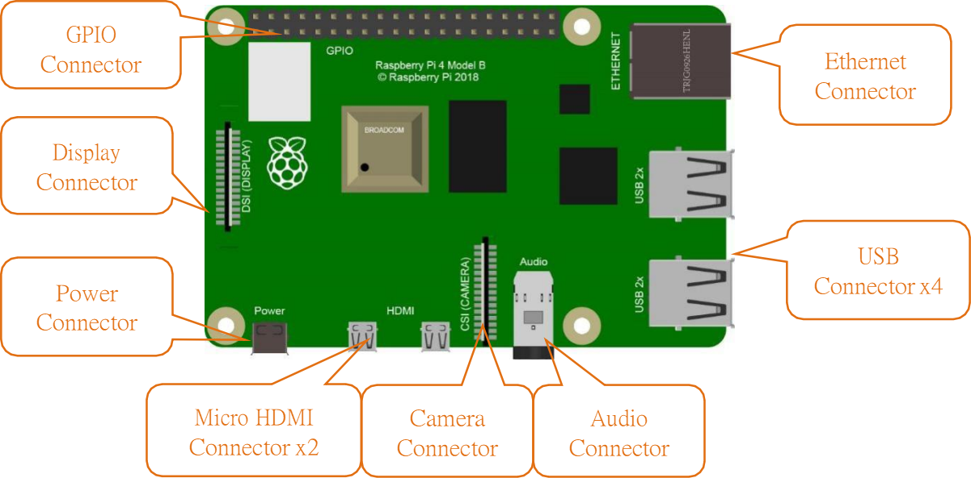

Hardware interface diagram of RPi 3B+/3B/2B/1B+:

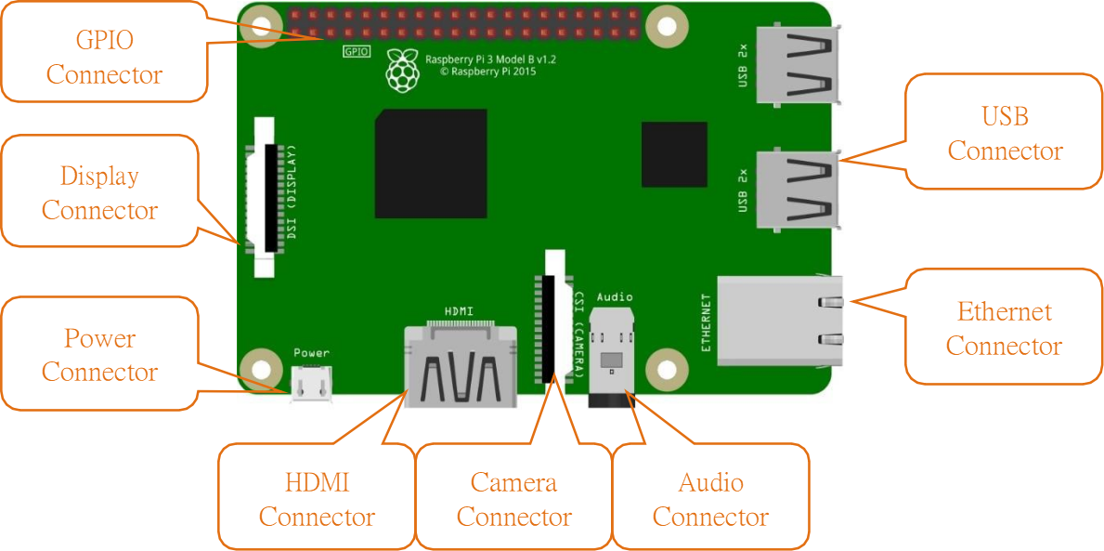

Hardware interface diagram of RPi 3A+/A+:

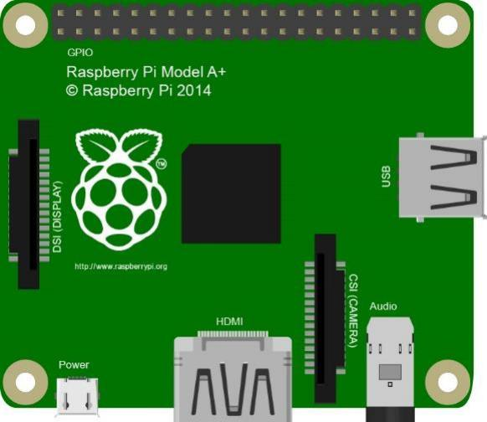

GPIO

Connector

Display

Connector

USB

Connector

Power

Connector

HDMI

Connector

Camera

Connector

Audio

Connector

Hardware interface diagram of RPi Zero/Zero W:

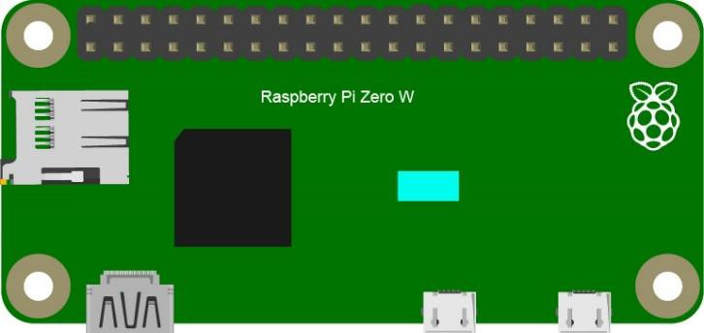

GPIO

Connector

Camera

Connector

HDMI

Connector

USB

Connector

Power

Connector

# 3.Installing an Operating System

The first step is to install an operating system on your RPi so that it can be programmed and function. If you have installed a system in your RPi, you can begin use the raspberry pi .

## 3.1Component List

Required Components

|  |  |
| --- | --- |
| Any Raspberry Pi with 40 GPIO | 5V/3A Power Adapter. Note: Different versions of Raspberry Pi have different power requirements (please check the power requirements for yours on the chart in the following page.) |
| Micro or Type-C USB Cable x1 | Micro SD Card (TF Card) x1, Card Reader x1 |

Power requirements of various versions of Raspberry Pi are shown in following table:

|  |  |  |  |
| --- | --- | --- | --- |
| **Product** | **Recommended PSU current**  **capacity** | **Maximum total USB peripheral current draw** | **Typical bare-board active current**  **consumption** |
| **Raspberry Pi Model A** | 700mA | 500mA | 200mA |
| **Raspberry Pi Model B** | 1.2A | 500mA | 500mA |
| **Raspberry Pi Model A+** | 700mA | 500mA | 180mA |
| **Raspberry Pi Model B+** | 1.8A | 600mA/1.2A (switchable) | 330mA |
| **Raspberry Pi 2 Model B** | 1.8A | 600mA/1.2A (switchable) | 350mA |
| **Raspberry Pi 3 Model B** | 2.5A | 1.2A | 400mA |
| **Raspberry Pi 3 Model A+** | 2.5A | Limited by PSU, board, and  connector ratings only. | 350mA |
| **Raspberry Pi 3 Model B+** | 2.5A | 1.2A | 500mA |
| **Raspberry Pi 4 Model B** | 3.0A | 1.2A | 600mA |
| **Raspberry Pi Zero W** | 1.2A | Limited by PSU, board, and  connector ratings only. | 150mA |
| **Raspberry Pi Zero** | 1.2A | Limited by PSU, board, and  connector ratings only | 100mA |

For more details, please refer to [https://www.raspberrypi.org/help/faqs/#powerReqs](https://www.raspberrypi.org/help/faqs/" \l "powerReqs)

In addition, RPi also needs an Ethernet network cable used to connect it to a WAN (Wide Area Network).

All these components are necessary for any of your projects to work. Among them, the power supply of at least 5V/2.5A, because a lack of a sufficient power supply may lead to many functional issues and even damage your RPi, we STRONGLY RECOMMEND a 5V/2.5A power supply. We also recommend using a SD Micro Card with a capacity of 16GB or more (which, functions as the RPI’s “hard drive”) and is used to store the operating system and necessary operational files.

## 3.2 Optional Components

Under normal circumstances, there are two ways to login to Raspberry Pi: 1) Using a stand-alone monitor. 2) Using a remote desktop or laptop computer monitor “sharing” the PC monitor with your RPi.

Required Accessories for Monitor

If you choose to use an independent monitor, mouse and keyboard, you also need the following accessories:

A display with a HDMI interface

A Mouse and a Keyboard with an USB interface

As to Pi Zero and Pi Zero W, you also need the following accessories:

A Mini-HDMI to HDMI Adapter and Cable.

A Micro-USB to USB-A Adapter and Cable (Micro USB OTG Cable).

A USB HUB.

USB to Ethernet Interface or USB Wi-Fi receiver.

For different Raspberry Pi Modules, the optional items may vary slightly but they all aim to convert the interfaces to Raspberry Pi standards.

|  |  |  |  |  |  |  |  |
| --- | --- | --- | --- | --- | --- | --- | --- |
|  | **Pi Zero** | **Pi A+** | **Pi Zero**  **W** | **Pi 3A+** | **Pi B+/2B** | **Pi**  **3B/3B+** | **Pi 4B** |
| **Monitor** | Yes (All) | | | | | | |
| **Mouse** | Yes (All) | | | | | | |
| **Keyboard** | Yes (All) | | | | | | |
| **Micro-HDMI to HDMI**  **Adapter & Cable** | Yes | No | Yes | No | No | No | No |
| **Micro-HDMI to HDMI**  **Adapter & Cable** | No | | | | | | Yes |
| **Micro-USB to USB-A Adapter & Cable (Micro USB OTG**  **Cable)** | Yes | No | Yes | No | | | |
| **USB HUB** | Yes | Yes | Yes | Yes | No | No |  |
| **USB to Ethernet**  **Interface** | select one from  two or select two from two | | optional | | Internal  Integration | Internal Integration | |
| **USB Wi-Fi Receiver** | Internal Integration | | optional |

Required Accessories for Remote Desktop

If you do not have an independent monitor, or if you want to use a remote desktop, you first need to login to Raspberry Pi through SSH, and then open the VNC or RDP service. This requires the following accessories.

|  |  |  |  |  |  |  |
| --- | --- | --- | --- | --- | --- | --- |
|  | **Pi Zero** | **Pi Zero W** | **Pi A+** | **Pi 3A+** | **Pi B+/2B** | **Pi 3B/3B+/4B** |
| **Micro-USB to USB-A Adapter & Cable (Micro USB OTG**  **Cable)** | Yes | Yes | No | NO | | |
| **USB to Ethernet**  **interface** | Yes | Yes | Yes |

## 3.3 Raspberry Pi OS

**Without Screen - Use Raspberry Pi - under Windows PC:** <https://youtu.be/YND0RUuP-to>

**With Screen - Use Raspberry Pi - under Windows PC:** <https://youtu.be/HEywFsFrj3I>

Automatically Method

You can follow the official method to install the system for raspberry pi via visiting link below: <https://projects.raspberrypi.org/en/projects/raspberry-pi-setting-up/2>

In this way, the system will be downloaded automatically via the application.

Manually Method

Install Raspberry Pi Imager

Visit the official website of Raspberry Pi to download through a browser: https://[www.raspberrypi.org/downloads/](http://www.raspberrypi.org/downloads/)

* For Windows OS, click "Download for Windows" to download.
* For Mac OS, click "Download for macOS" to download.
* For Linux OS, Click "Download for Ubuntu for x86" to download.

After the download is complete, install the software and burn the Raspberry Pi OS . Now take Windows as an example.

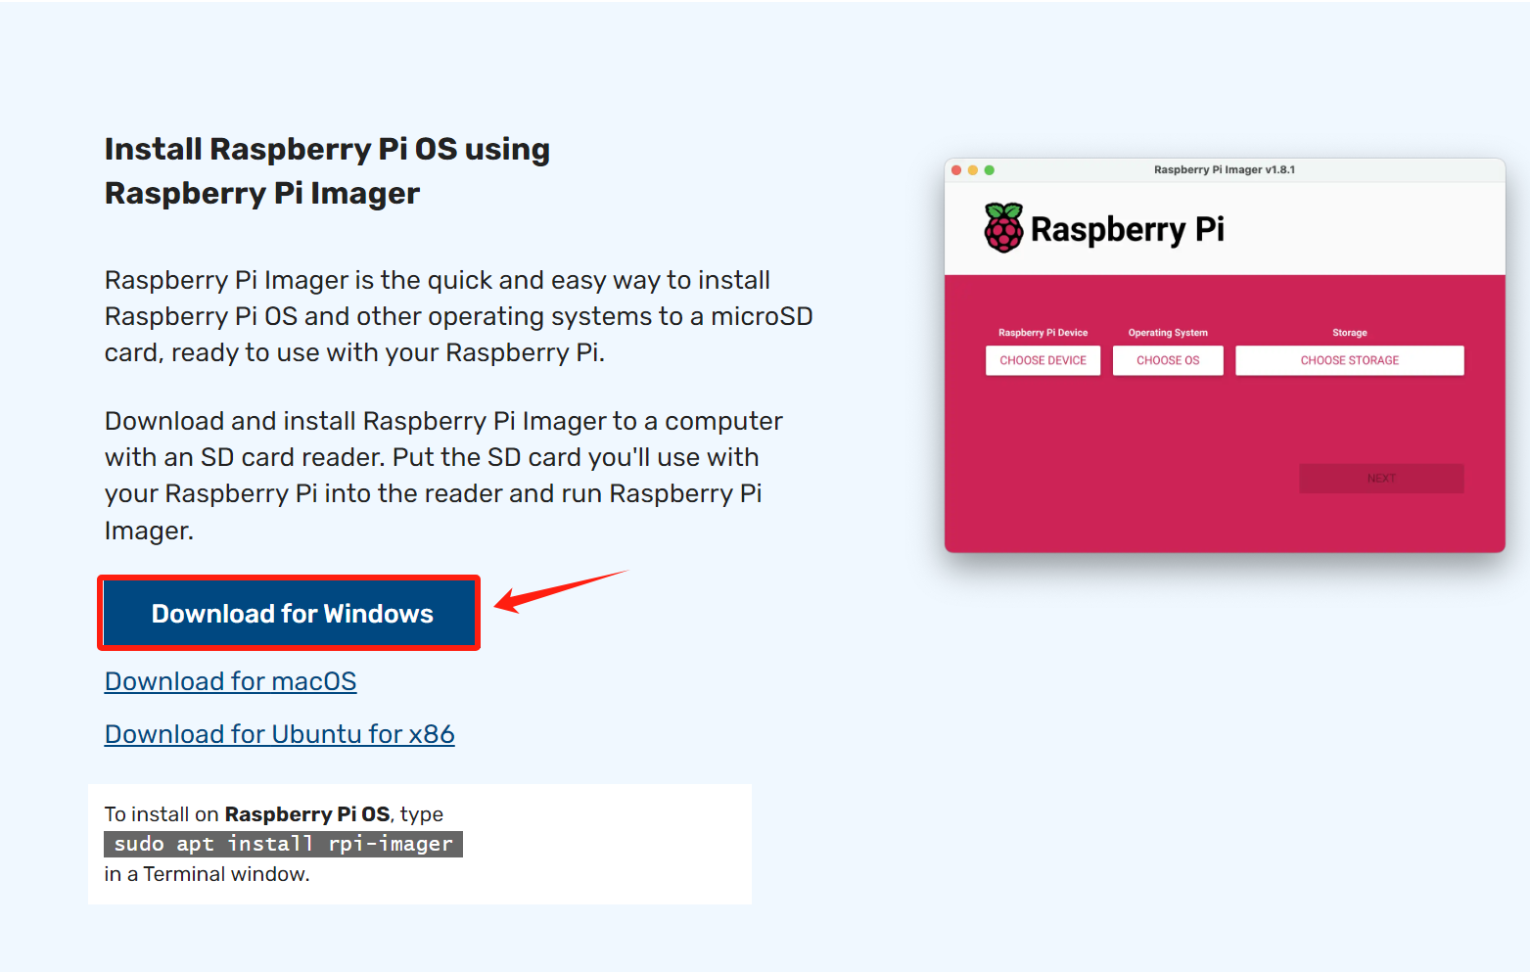

Open the downloaded file "imager.exe" and click "Install".

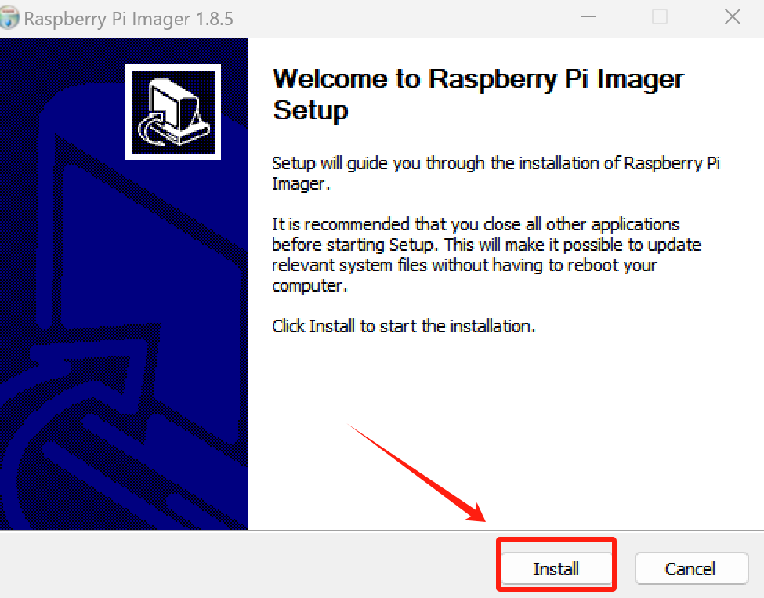

Then click "Finish".

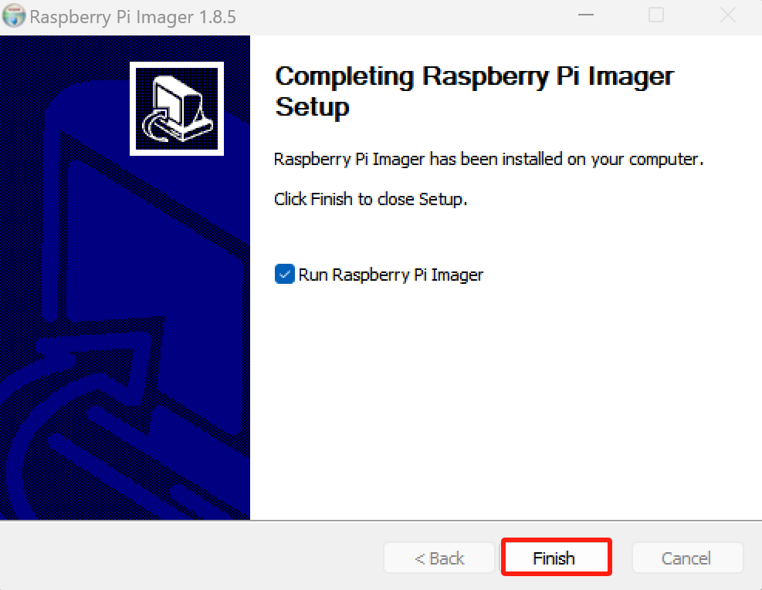

The software interface after opening is as shown below:

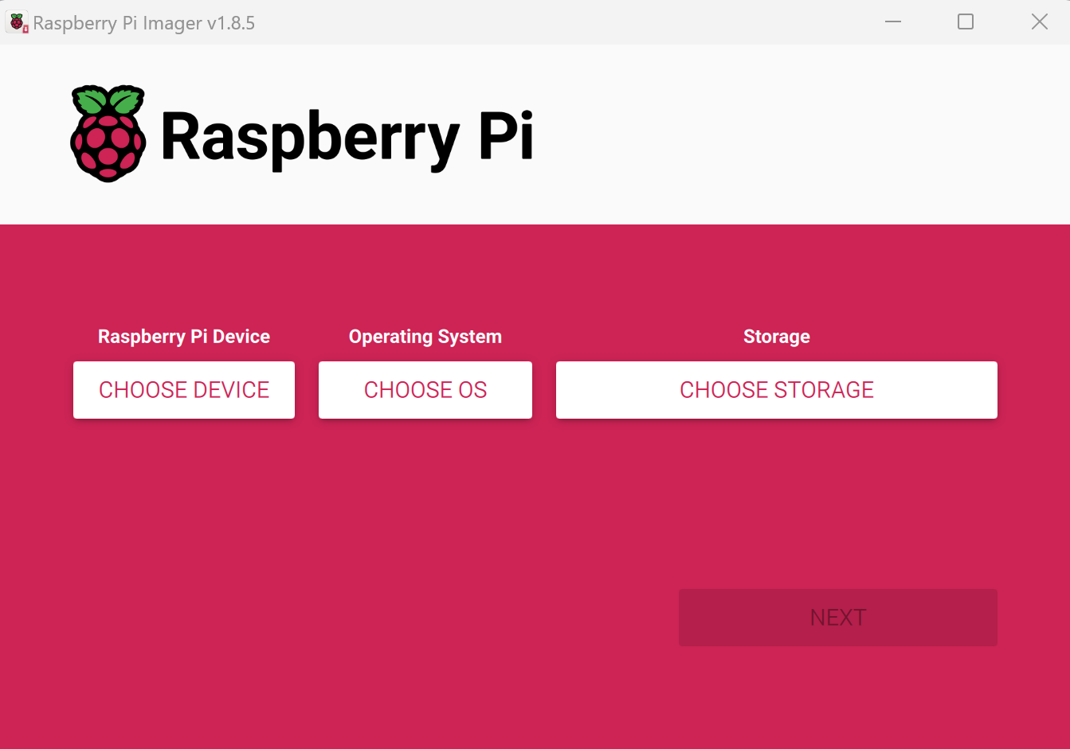

After installing the Imager Tool in the link above. You can also download the system manually first. Visit <https://www.raspberrypi.org/downloads/>

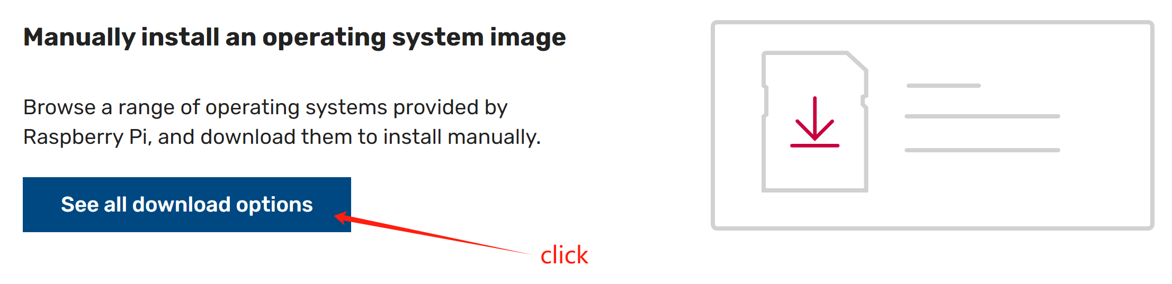

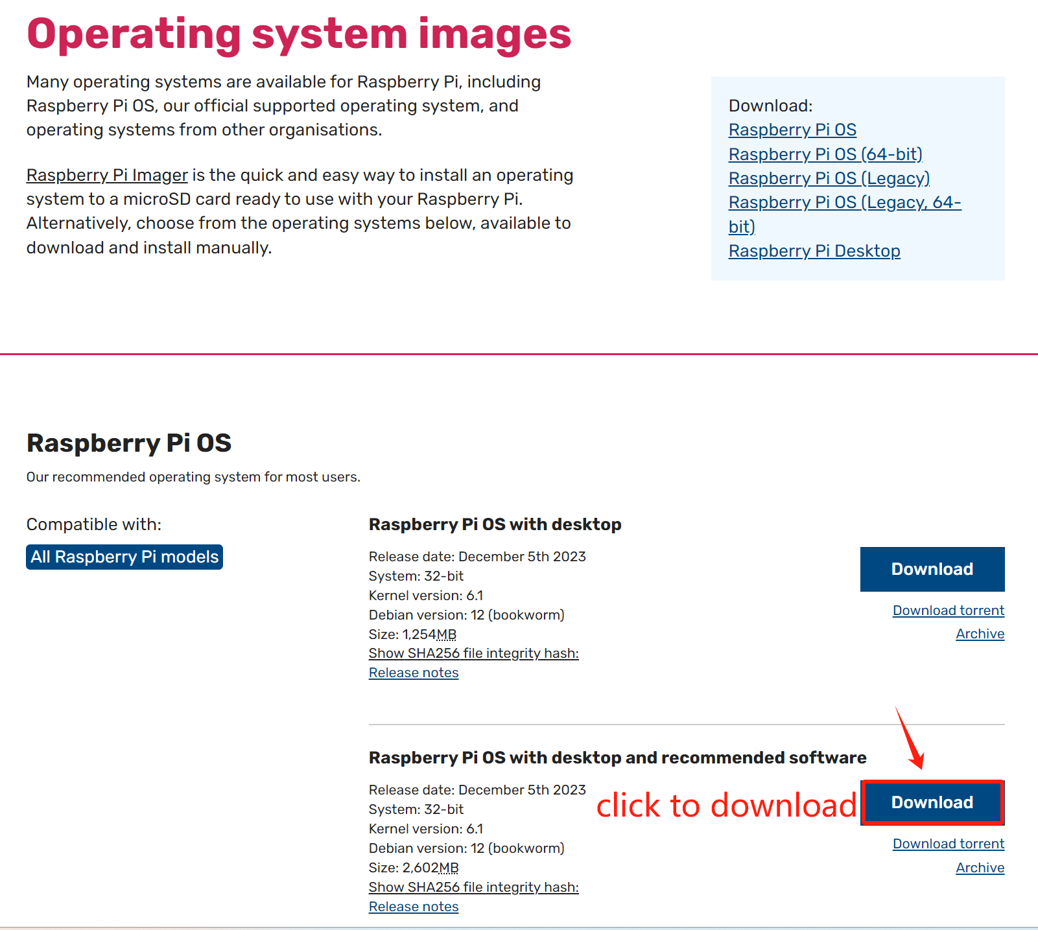

And then the zip file is downloaded.

## 3.4Write System to Micro SD Card

First, put your Micro SD card into card reader and connect it to USB port of PC.

Then open imager tool. Choose Raspberry Pi Device that you want to use.

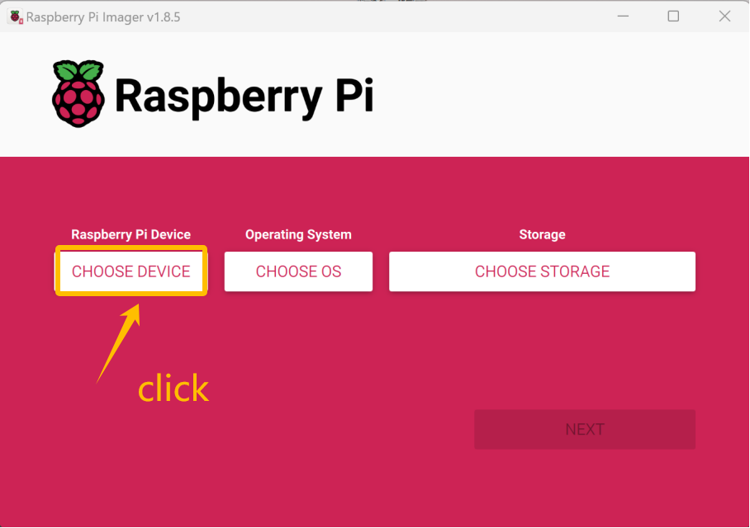

For example,we choose the Raspberry Pi4 .

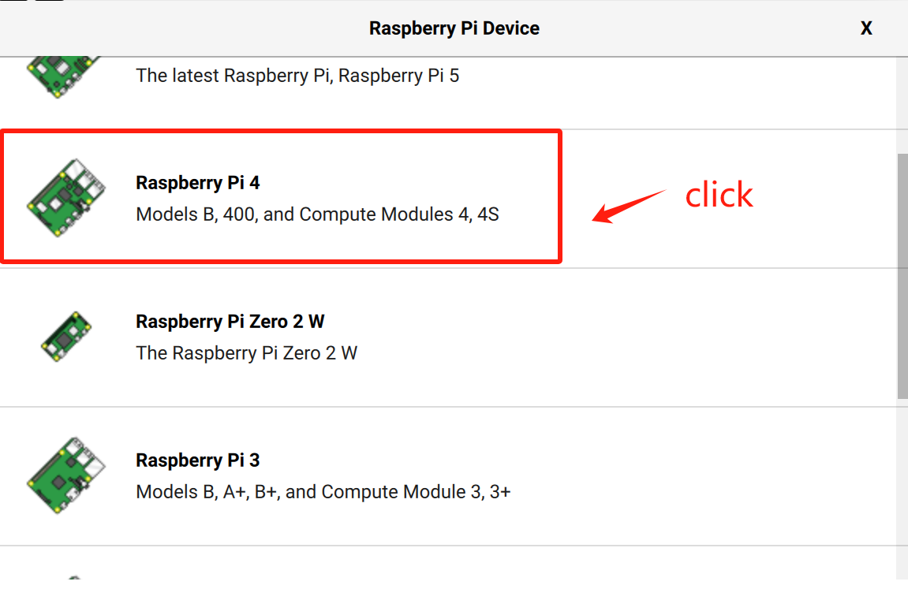

Choose system that you just downloaded in Use custom.

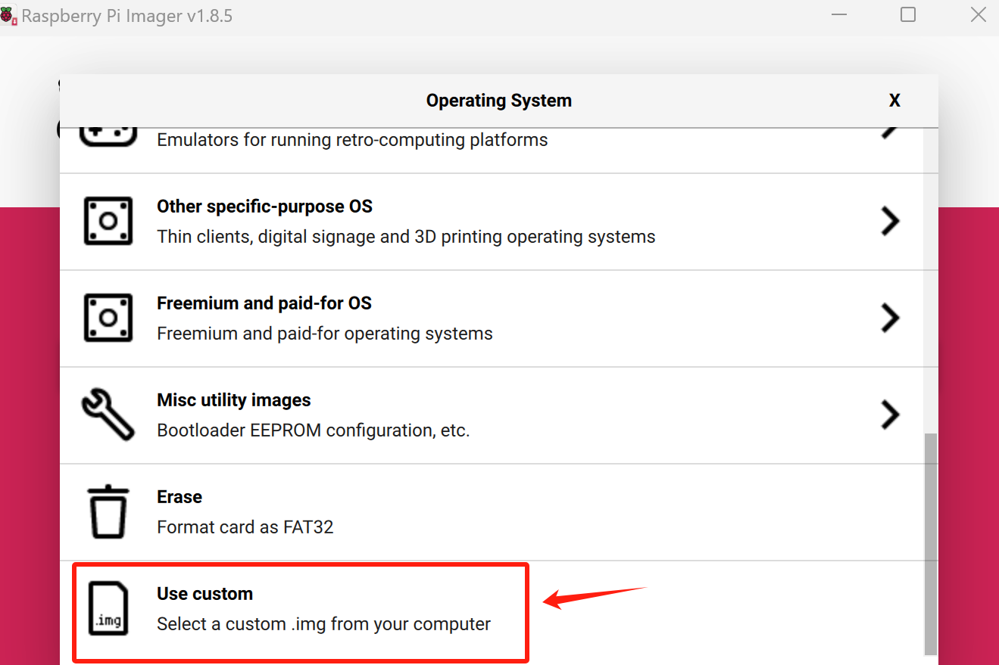

For example,the system that download stored in the F disk of our computer.

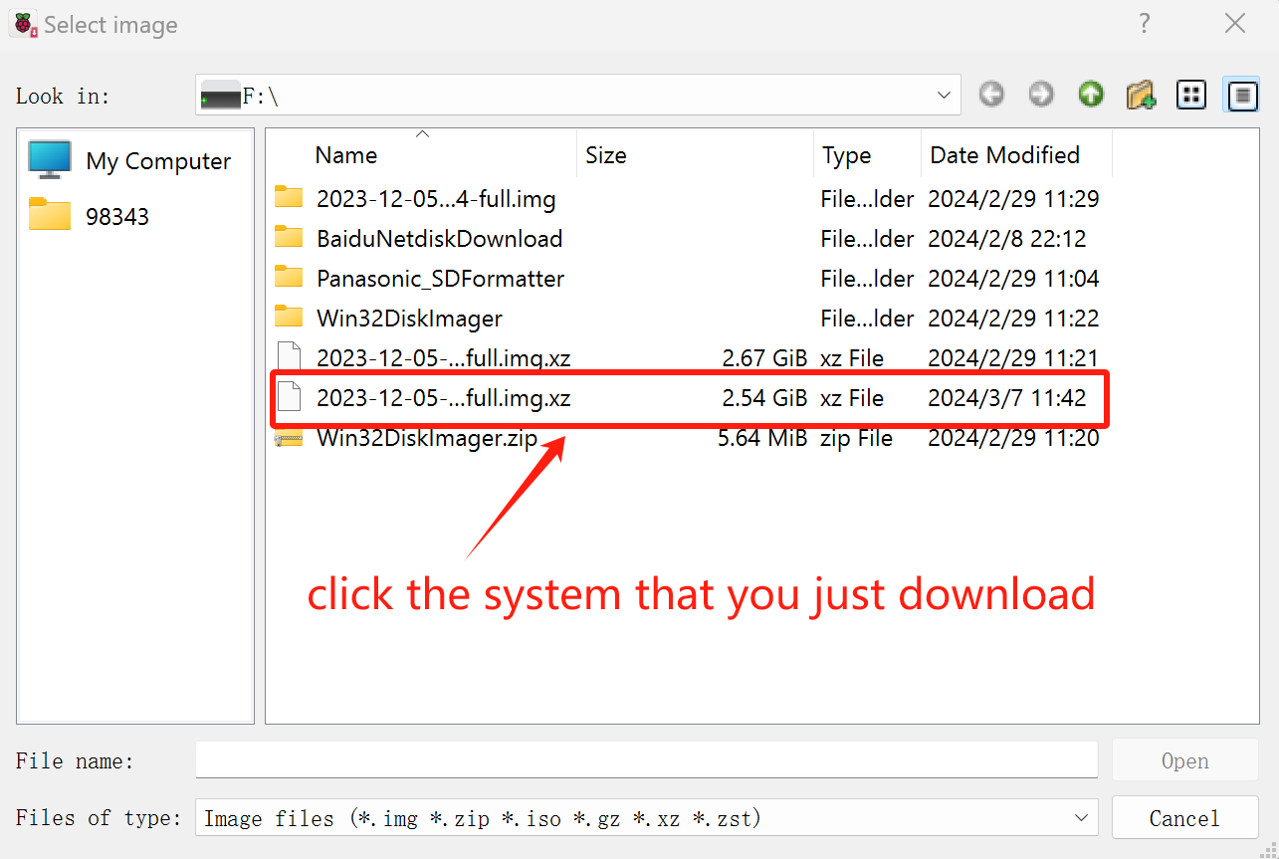

Choose the SD card.

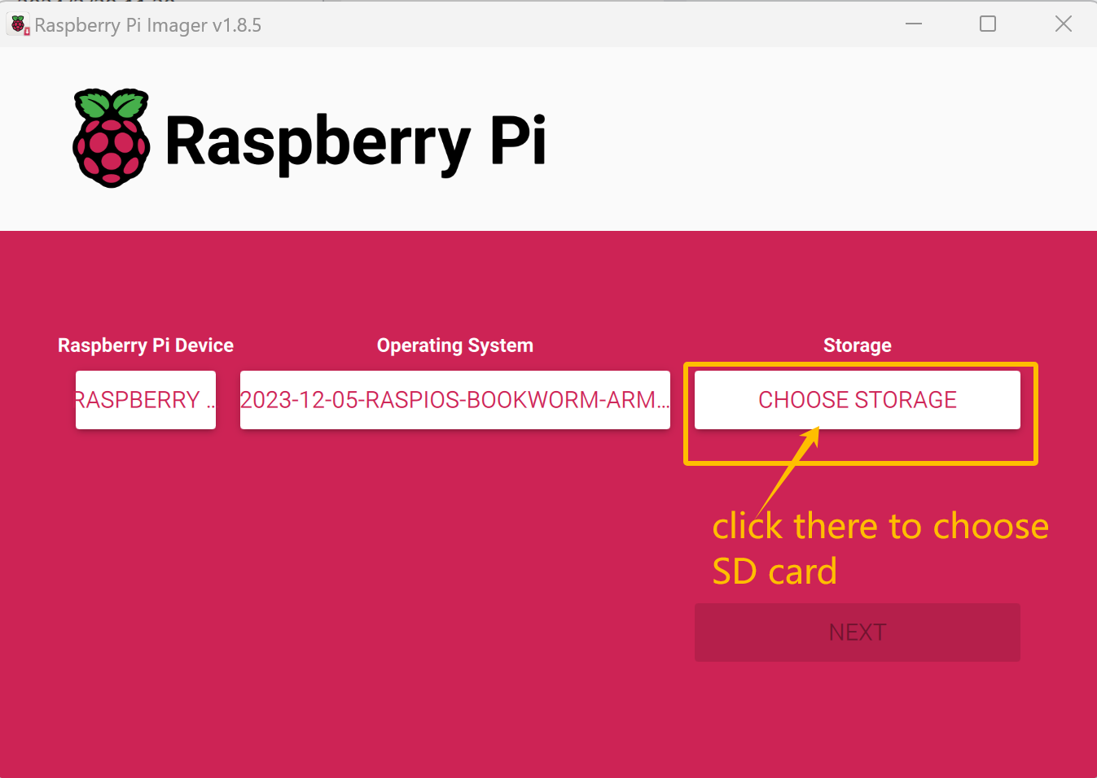

For example, the SD card connect to my computer is H disk,click it to choose.

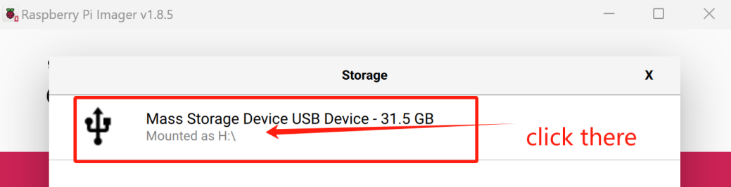

Then,click the “NEXT”

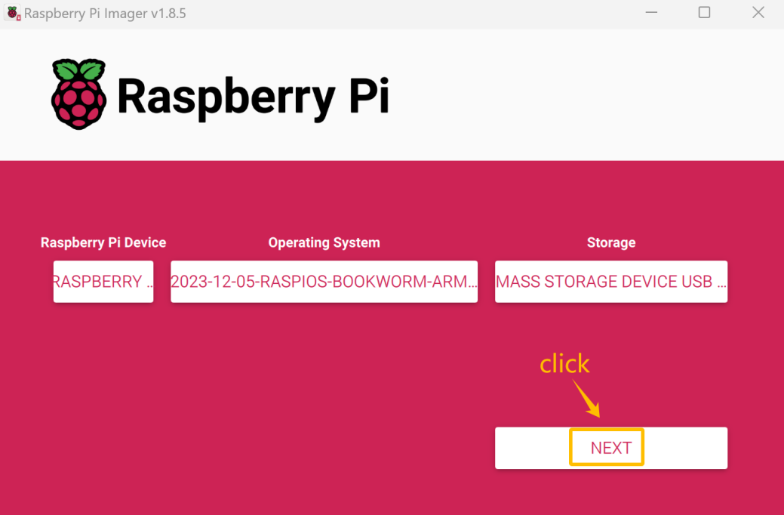

## 3.5Enable ssh and configure WiFi

There will pop up prompt “Would you like to apply OS customization settings”,click “EDIT SETTINGS”

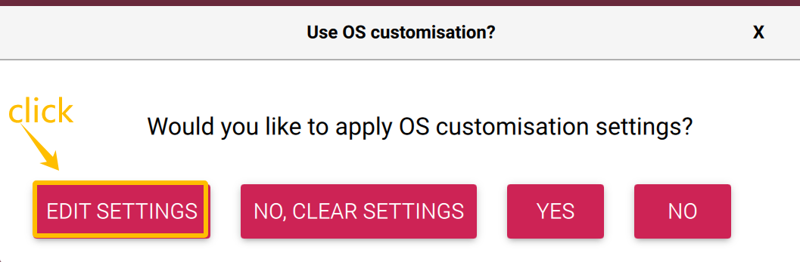

Click “SERVICES”,choose“Enable SSH”and“Use password authentication”

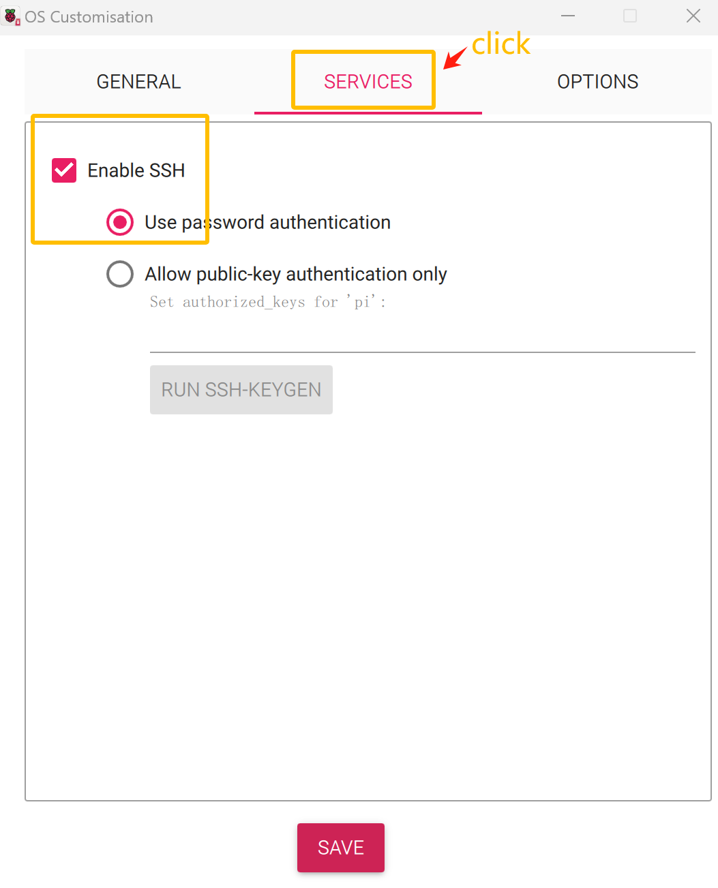

Then click“GENERAL”to set hostname“raspberrypi”,set username and password as “pi”and“raspberrypi”

Then configure wireless LAN,write your WiFi name and WiFi password.Click “SAVE” after all set up.

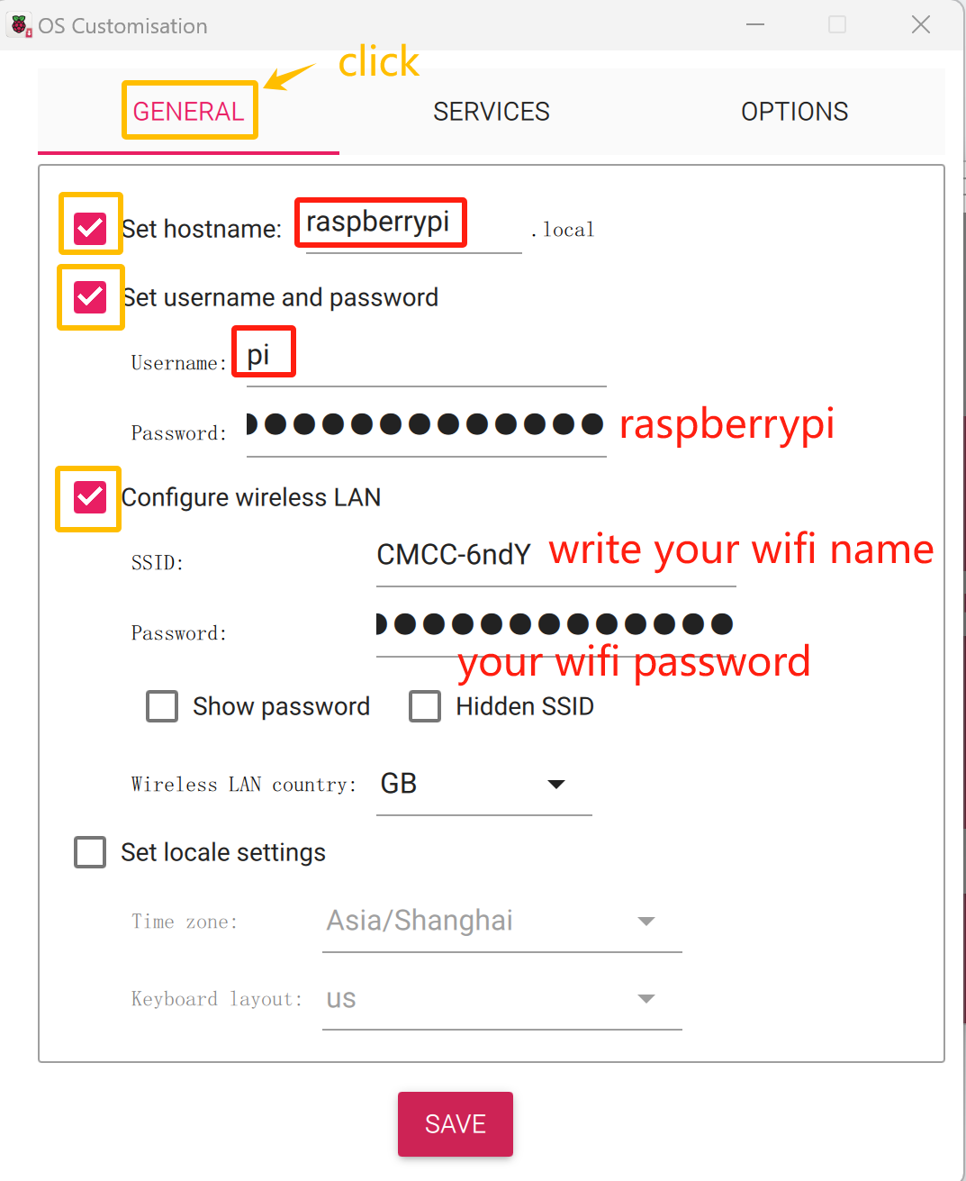

In“Use OS customisation”interface, click the“YES”

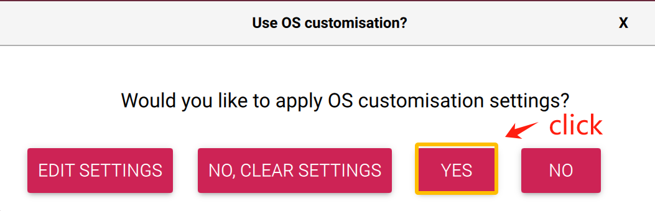

In the pop-up warning interface,click the “YES”

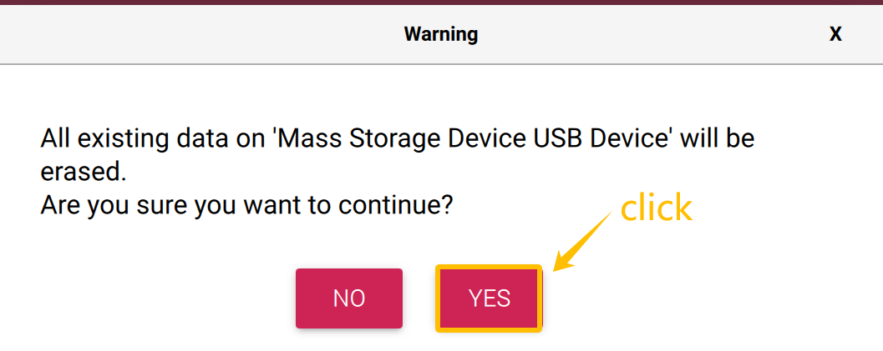

The Raspberry Pi system is writting to the SD card

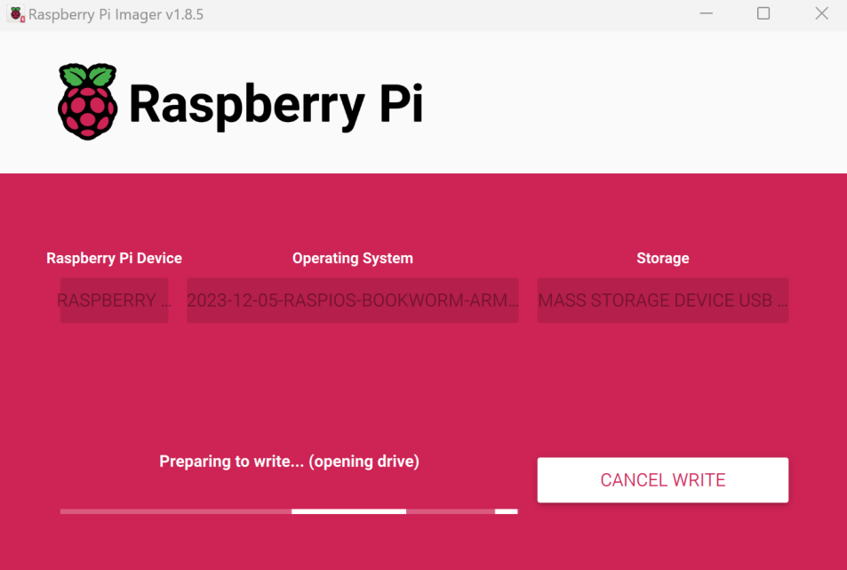

After waiting for about half an hour, the system successfully writes to the SD card and clicks "Continuue" to exit.

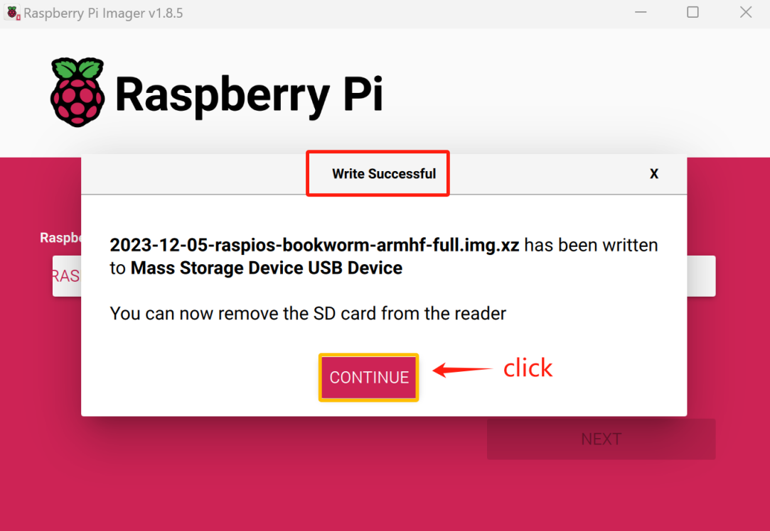

## 3.6 Insert SD card

Then remove SD card from card reader and insert it into Raspberry Pi.

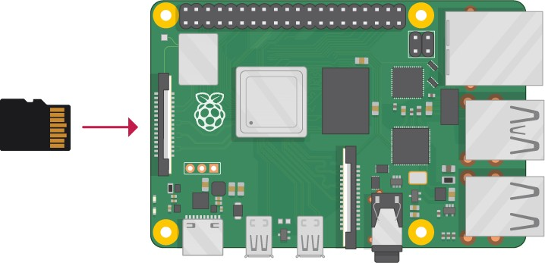

# 4.Getting Started with Raspberry Pi

## 4.1 Monitor desktop

If you do not have a spare monitor, please skip to next section Remote desktop & VNC. If you have a spare monitor, please follow the steps in this section.

After the system is written successfully, take out Micro SD Card and put it into the SD card slot of RPi. Then connect your RPi to the monitor through the HDMI port, attach your mouse and keyboard through the USB ports, attach a network cable to the network port and finally, connect your power supply

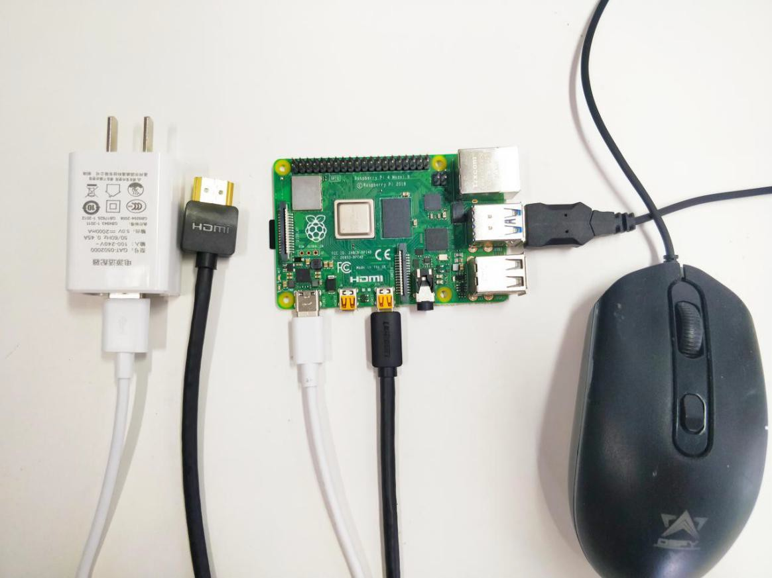

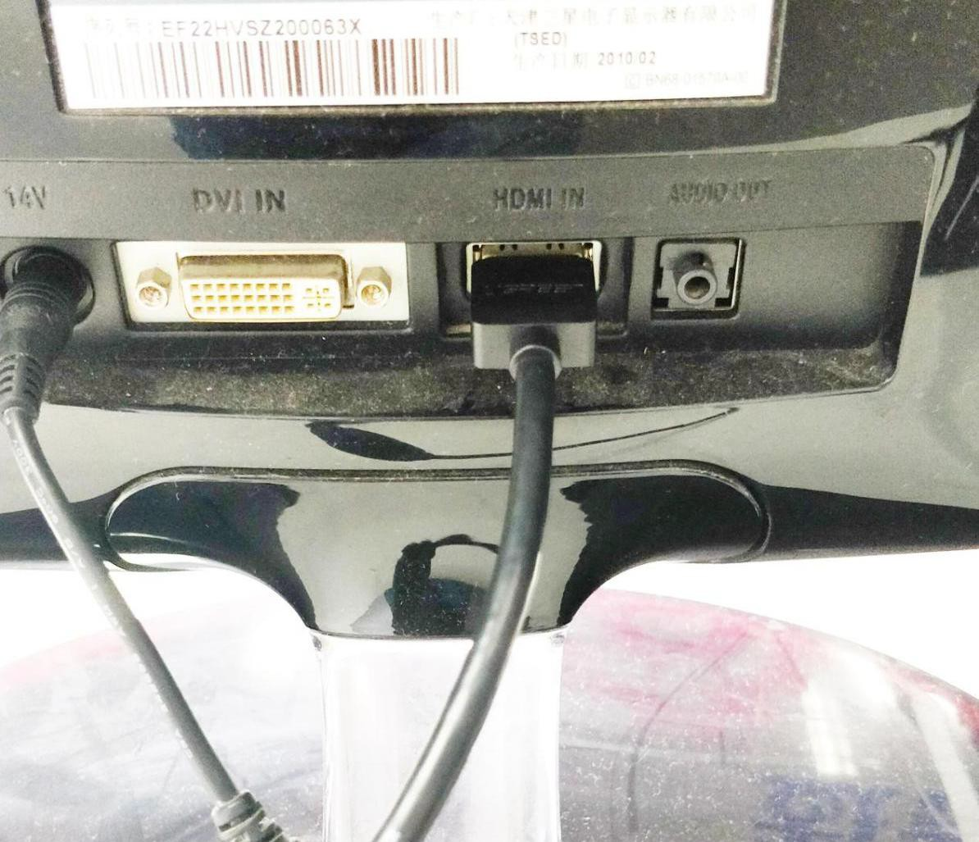

(making sure that it meets the specifications required by your RPi Module Version. Your RPi should start (power up). Later, after setup, you will need to enter your user name and password to login. The default user name: pi; password: raspberry. After login, you should see the following screen.

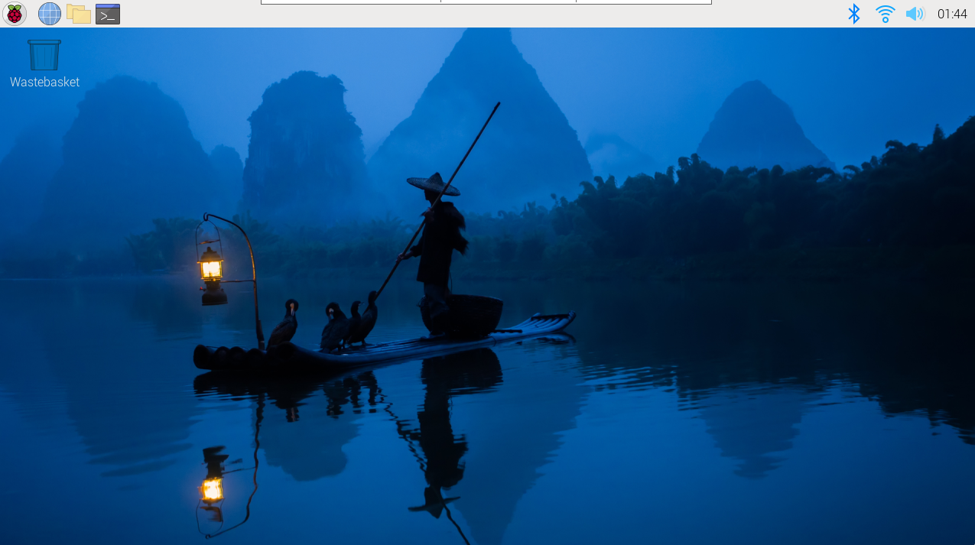

Congratulations! You have successfully installed the RASPBERRY PI OS operating system on your RPi.

Raspberry Pi 4B, 3B+/3B integrates a Wi-Fi adaptor. You can use it to connect to your Wi-Fi. Then you can use the wireless remote desktop to control your RPi. This will be helpful for the following work. Raspberry Pi of other models can use wireless remote desktop through accessing an external USB wireless card.

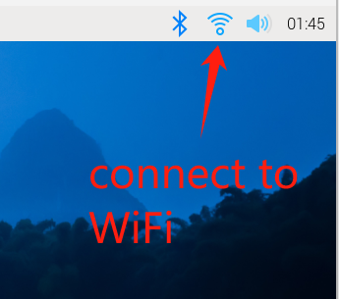

## 4.2 Remote desktop & VNC

###### If you have logged in Raspberry Pi via display, you can skip to VNC Viewer.

If you don't have a spare display, mouse and keyboard for your RPi, you can use a remote desktop to share a display, keyboard, and mouse with your PC. Below is how to use:

MAC OS remote desktop and Windows OS remote desktop.

### 4.2.1 MAC OS Remote Desktop

Open the terminal and type following command. **If this command doesn’t work, please move to next page.**

[ssh pi@raspberrypi.local](mailto:sshpi@raspberrypi.local)  The password is **raspberry** by default, case sensitive.

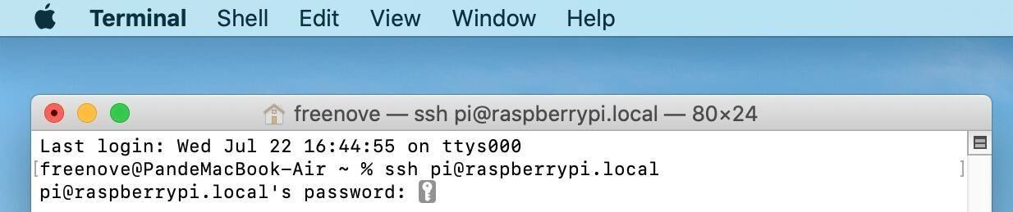

You may need to type **yes** during the process.

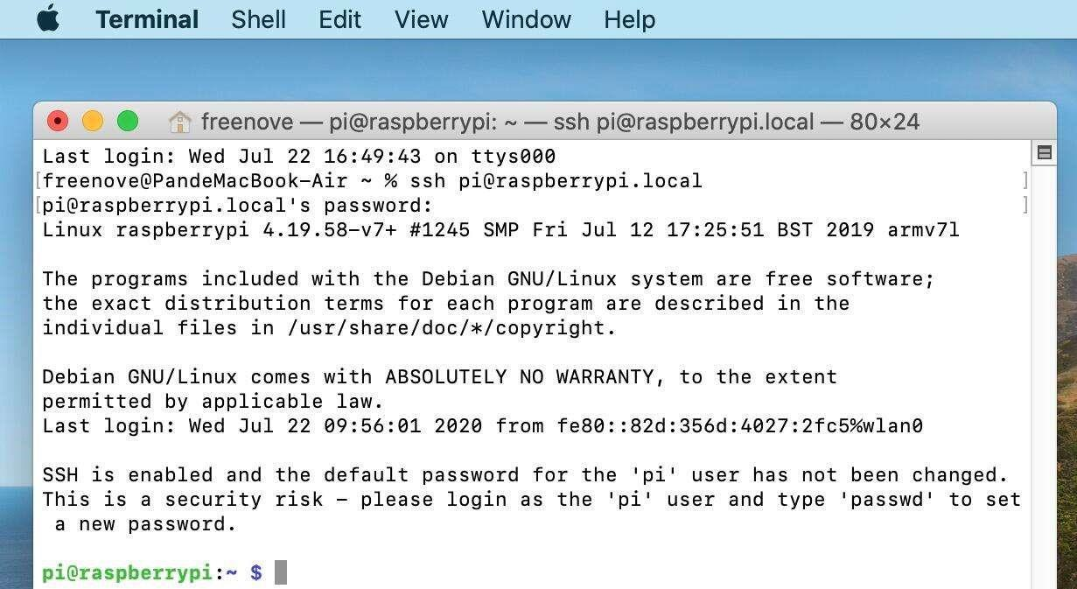

You can also use the IP address to log in Pi.

Enter **router** client to **inquiry IP address** named “raspberry pi”. For example, I have inquired to **my RPi IP address, and it is “192.168.1.131".**

Open the terminal and type following command.

[ssh pi@192.168.1.131](mailto:sshpi@192.168.1.131)  When you see **pi@raspberrypi**:**~ $,** you have logged in Pi successfully. Then you can skip to next section.

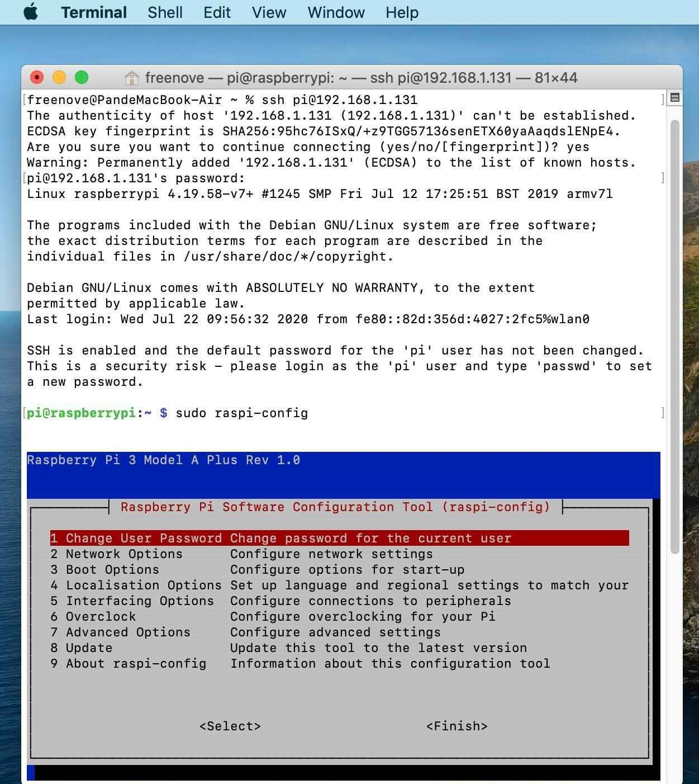

###### Then you can skip to VNC Viewer.

### 4.2.2 Windows OS Remote Desktop

###### If you are using win10, you can use follow way to login Raspberry Pi without desktop.

Press **Win+R**. Enter **cmd**. Then use this command to check IP:

ping -4 raspberrypi.local

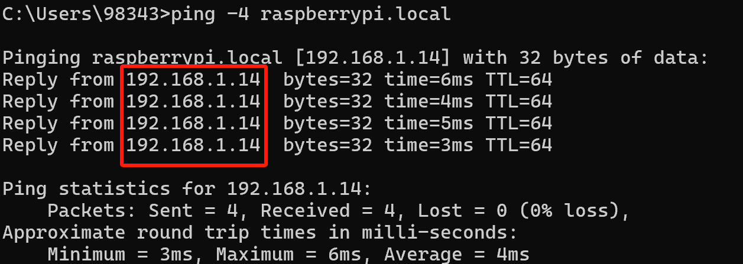

Then 192.168.1.14 is my Raspberry Pi IP.

Or enter **router** client to **inquiry IP address** named “**raspberrypi**”. For example, I have inquired to **my RPi IP address**, **and it is “192.168.1.14".**

ssh pi@xxxxxxxxxxx(IP address)

Enter the following command：

[ssh pi@192.168.1.14](mailto:sshpi@192.168.1.147)

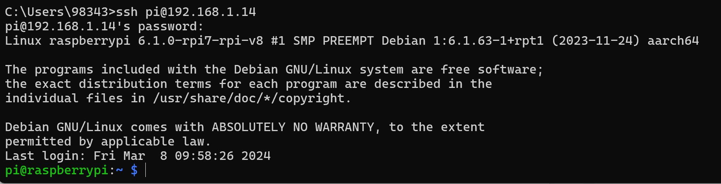

#### VNC Viewer & VNC

###### Enable VNC

Type the following command. And select Interface Options→P3 VNC → Enter→Yes→OK. Here Raspberry Pi may need be restarted, and choose ok. Then open VNC interface.

sudo raspi-config

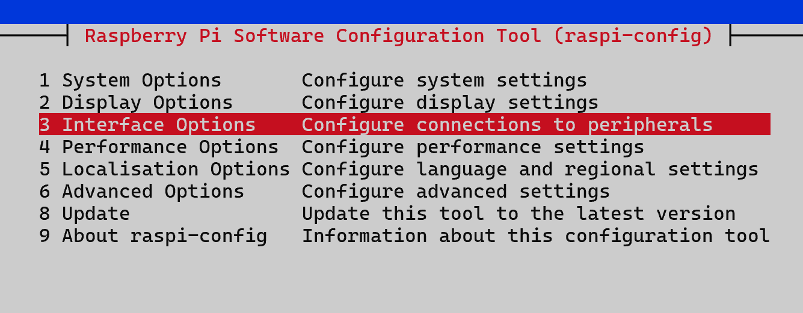

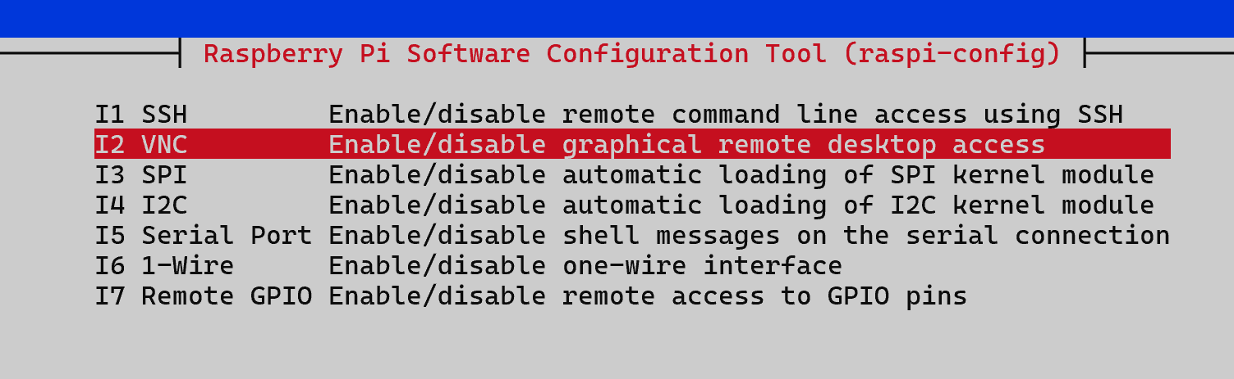

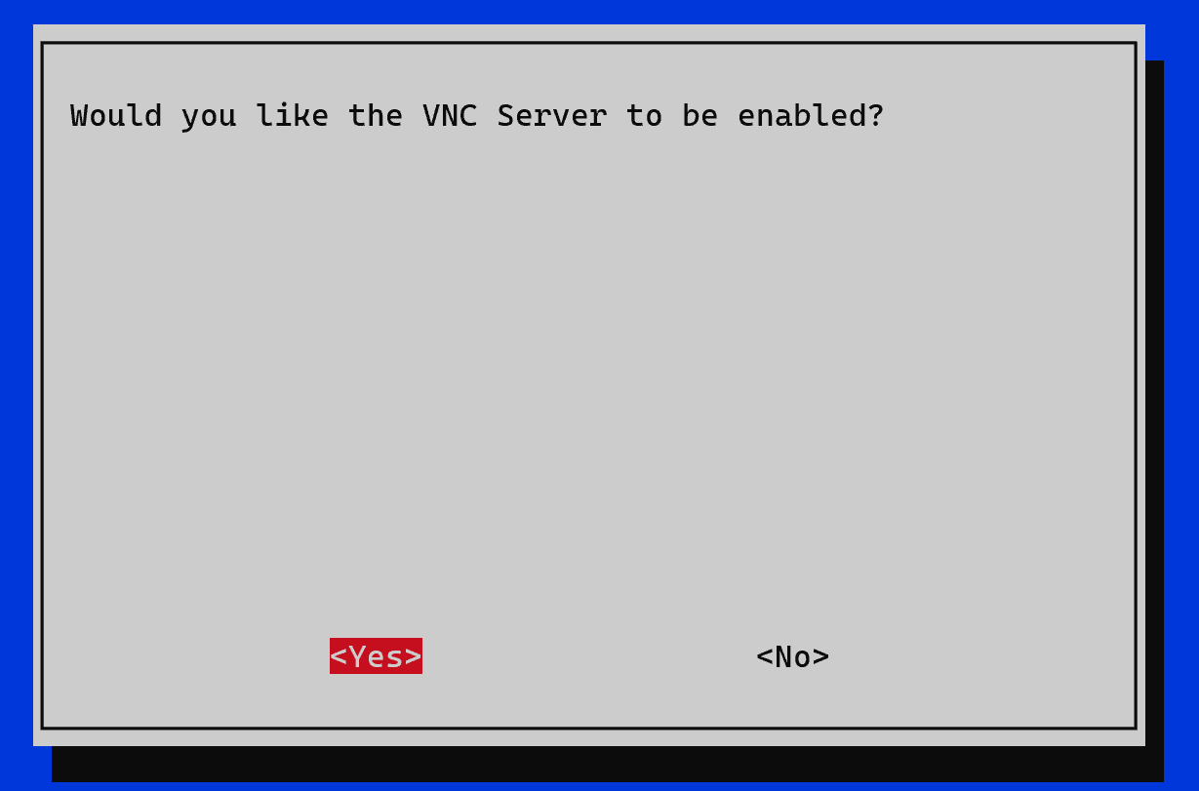

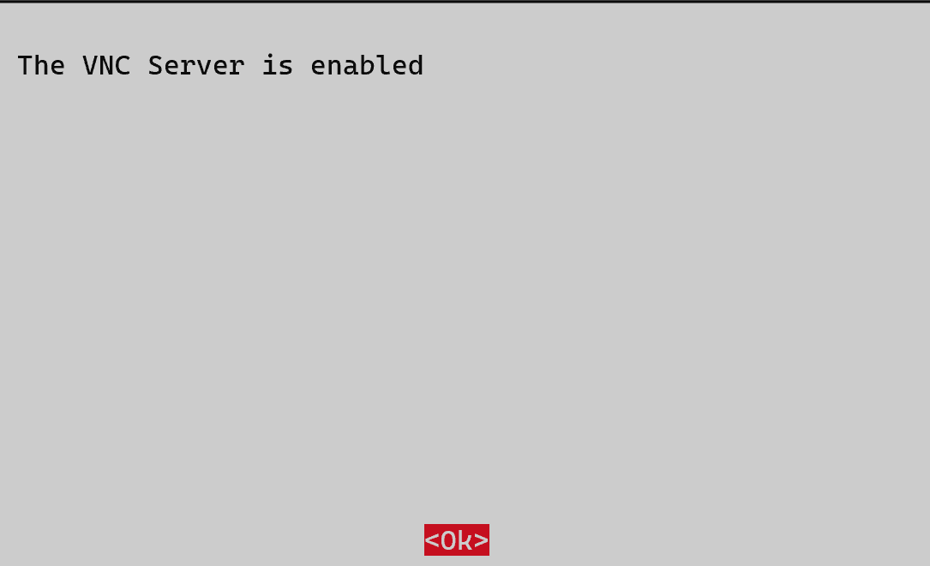

Set Resolution

You can also set other resolutions. If you don’t know what to set, you can set it as 1280x720 first.

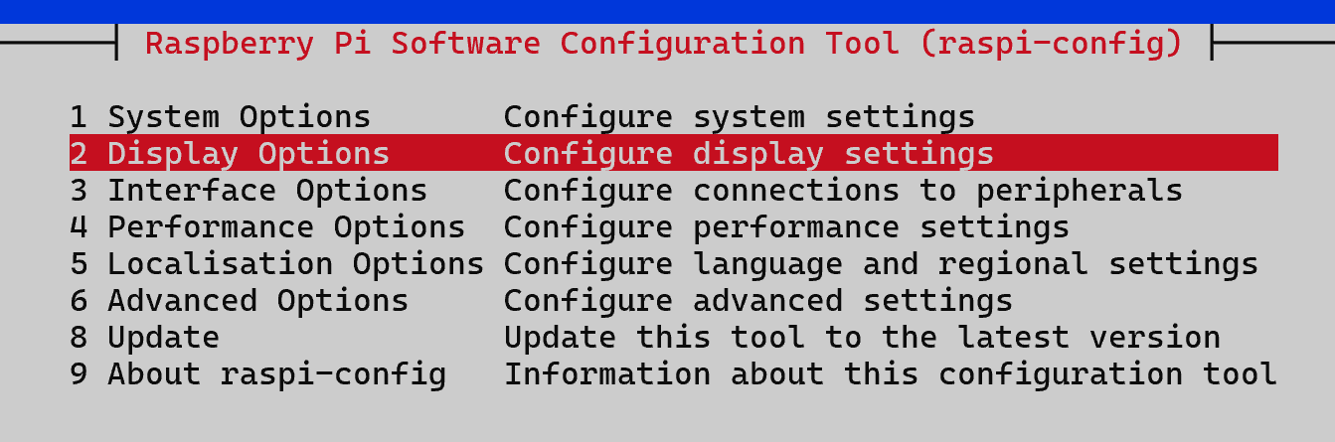

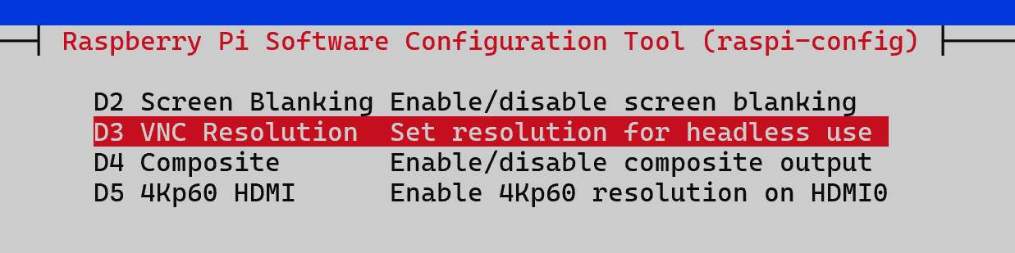

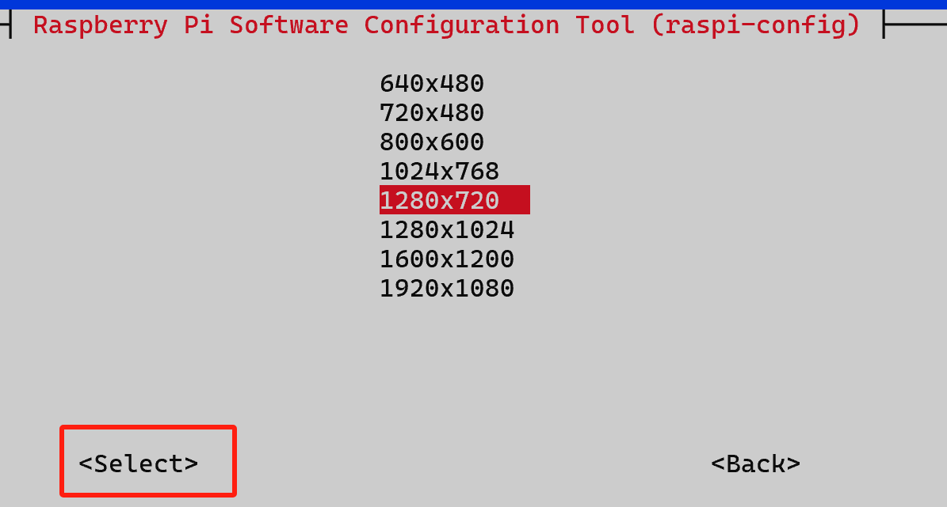

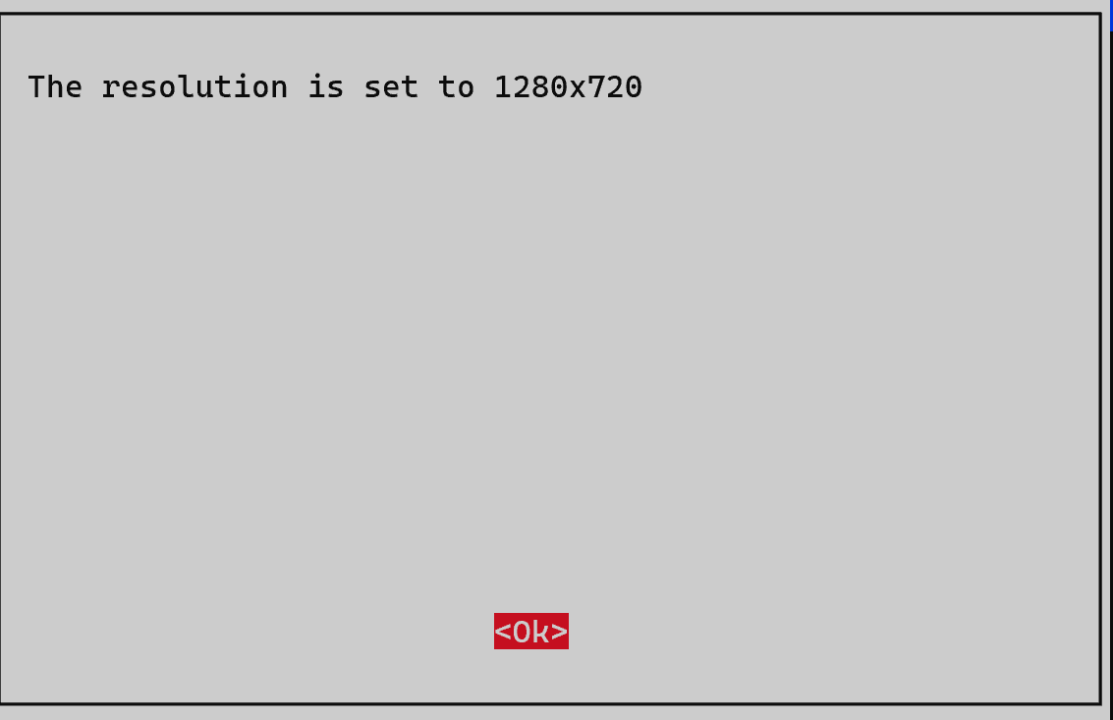

Then download and install VNC Viewer according to your computer system by click following link: <https://www.realvnc.com/en/connect/download/viewer/>

After installation is completed, open VNC Viewer. And click “File ”---“New Connection”. Then the interface is shown below.

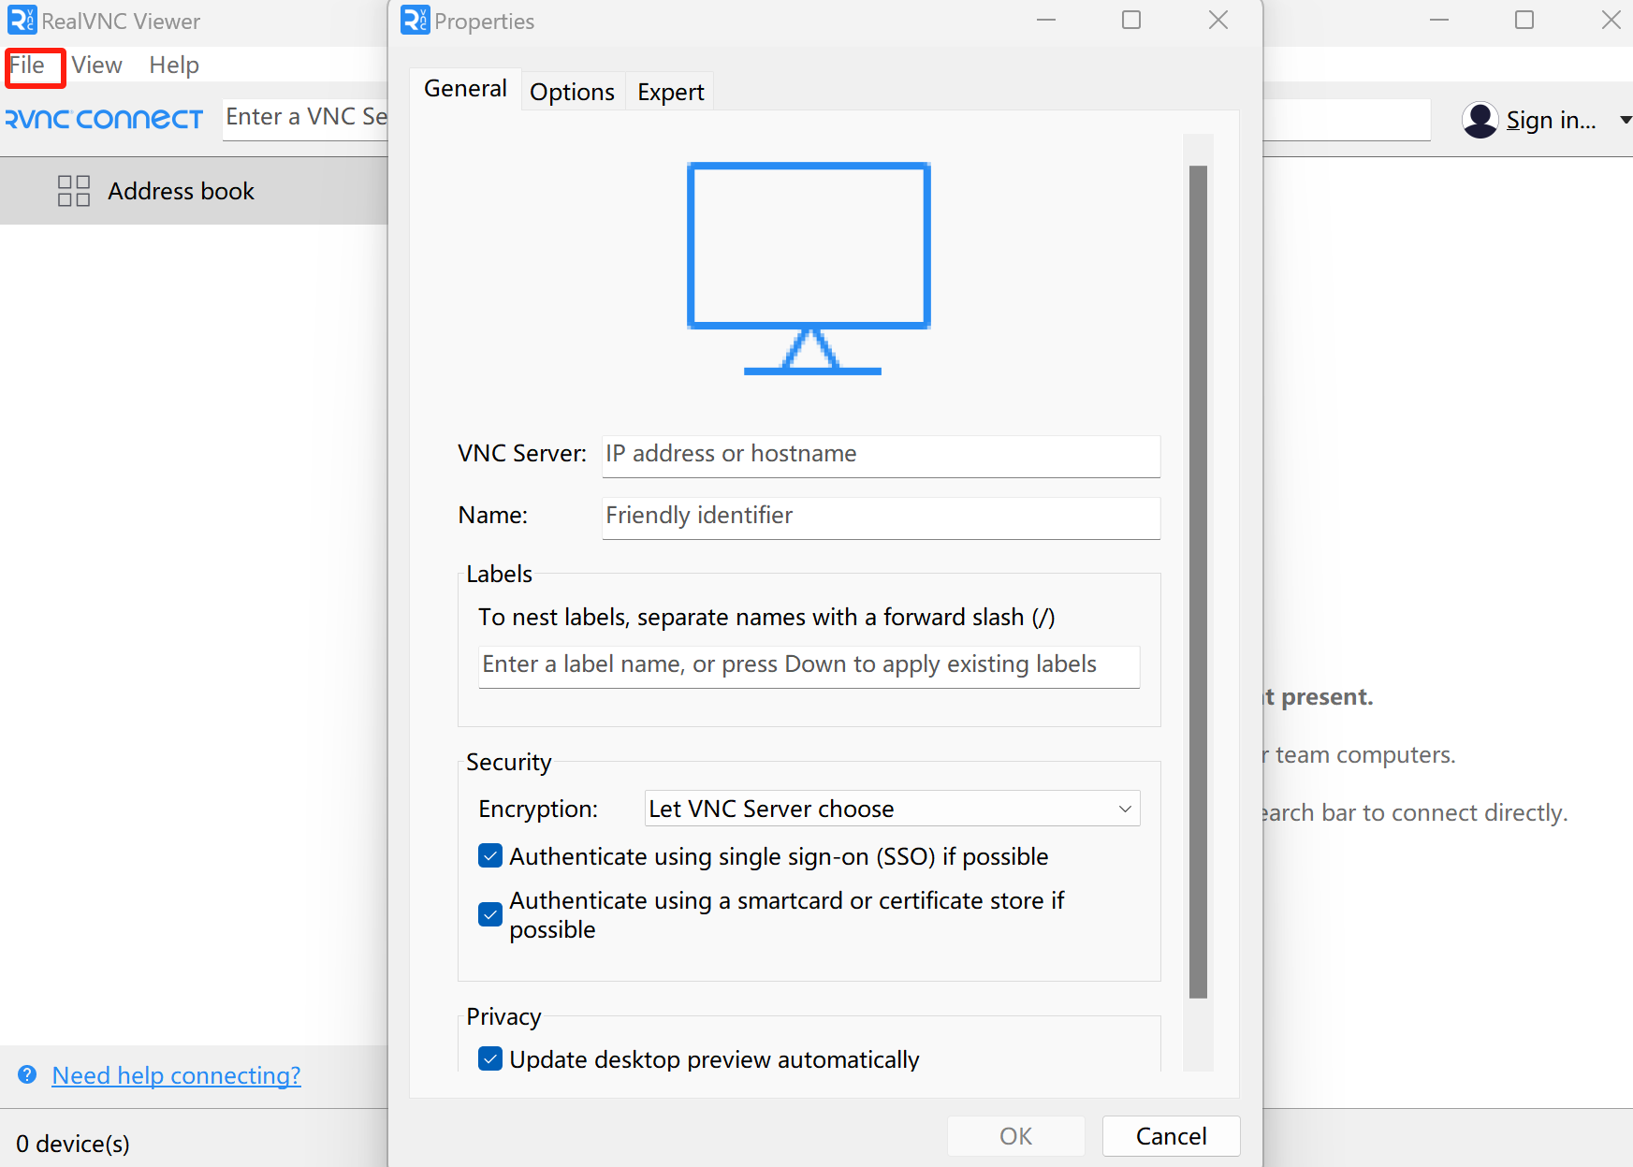

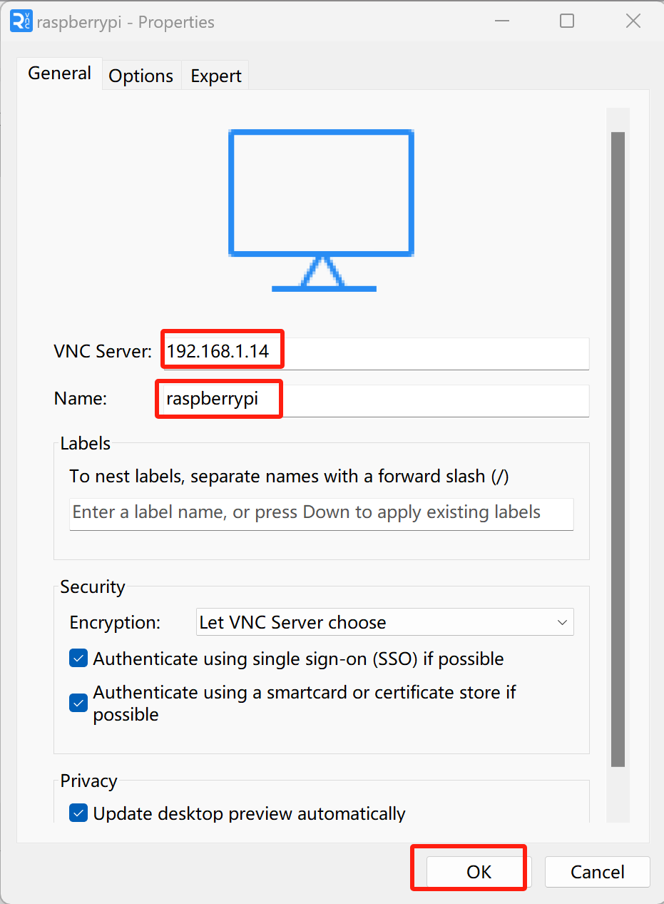

Enter ip address of your Raspberry Pi and fill in a name. Then click OK.

Then on the VNC Viewer panel, double-click new connection you just created.

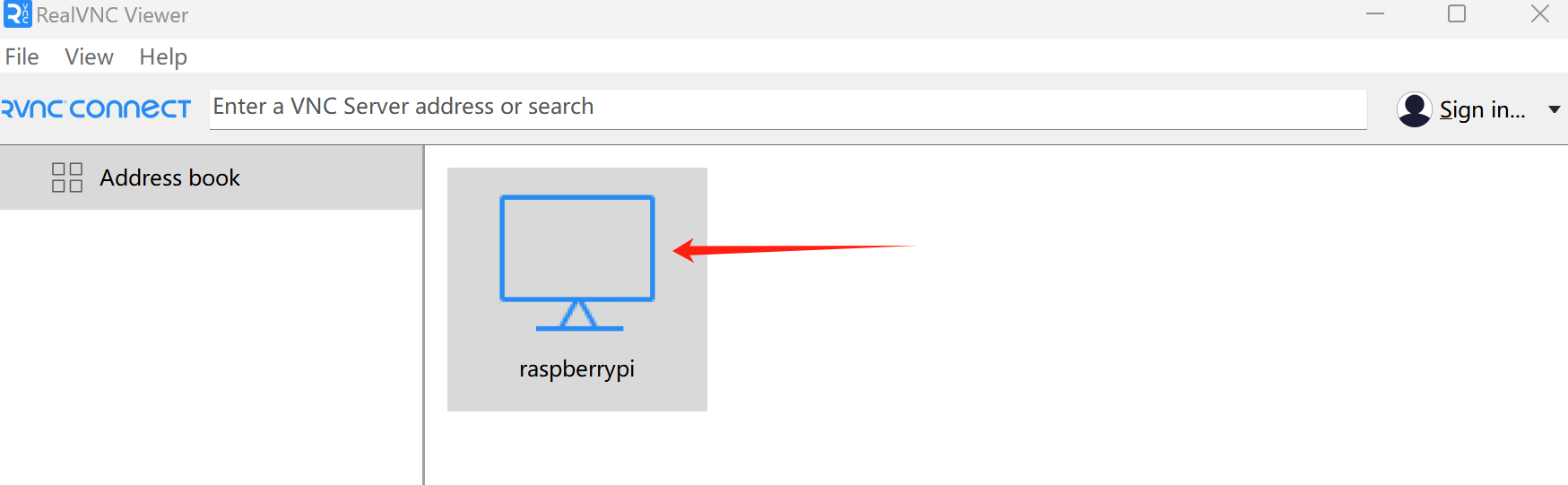

If there pop-up notication“VNC Server not recognized”,click“Continue”

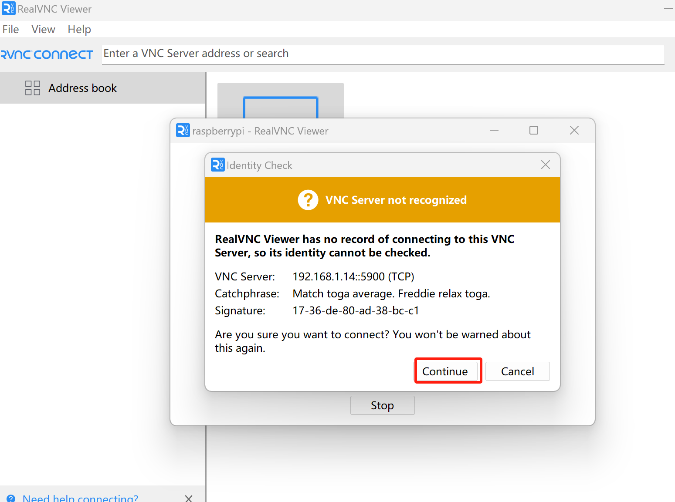

and the following dialog box pops up.

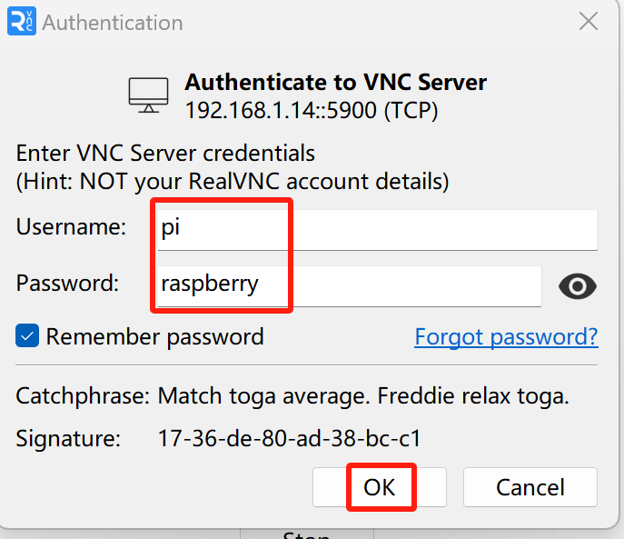

Enter username: **pi** and Password: **raspberry**. And click OK.Then the raspberry pi remote desktop is show on your computer like below.

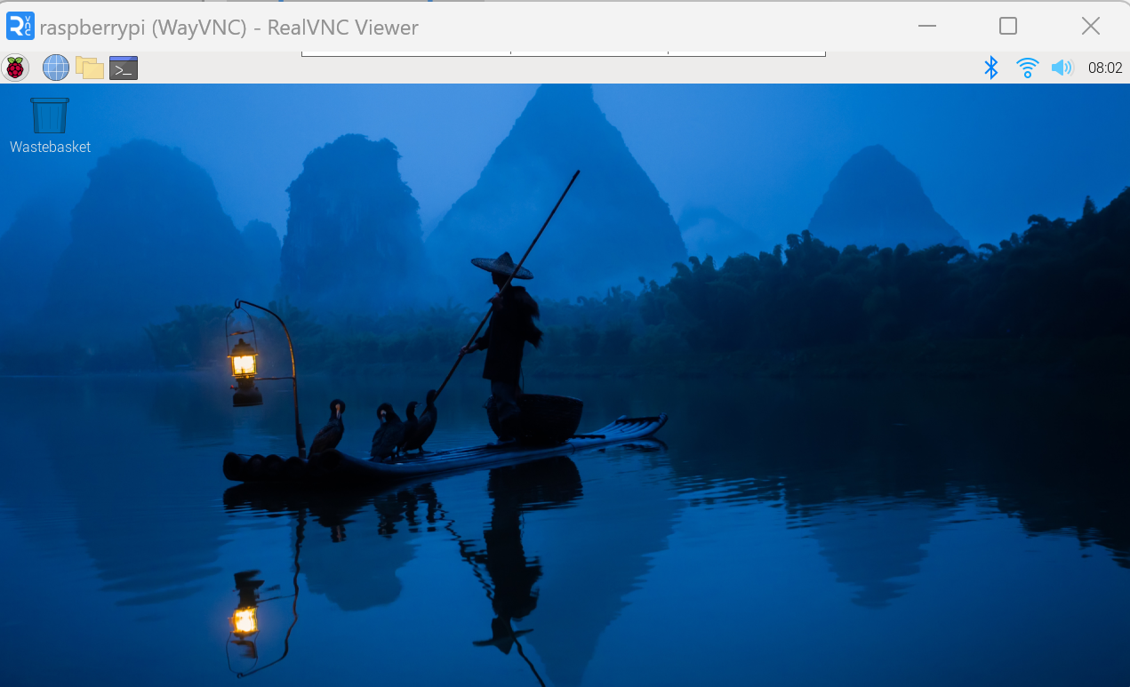

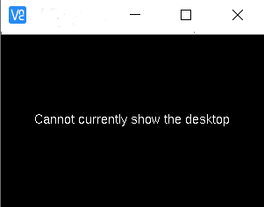Here, you have logged in to Raspberry Pi successfully by using VNC Viewer If there is black window, please **set another resolution**.

In addition, your VNC Viewer window may zoom your Raspberry Pi desktop. You can change it. On your VNC View control panel, click right key. And select Properties->Options label->Scaling. Then set proper scaling.

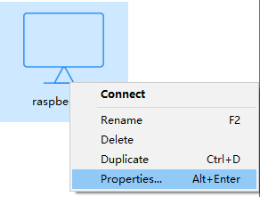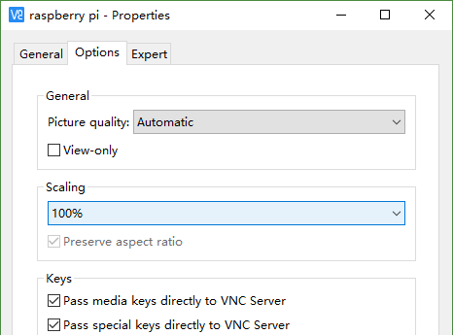

Here, you have logged in to Raspberry Pi successfully by using VNC Viewer and operated proper setting.

# 

# 5.Starting Preparation

We should do some necessary foundational preparation work: Start your Raspberry Pi and install some necessary libraries.

## 5.1 Linux Command

Raspberry Pi OS is based on the Linux Operation System. Now we will introduce you to some frequently used Linux commands and rules.

First, open the Terminal. All commands are executed in Terminal.

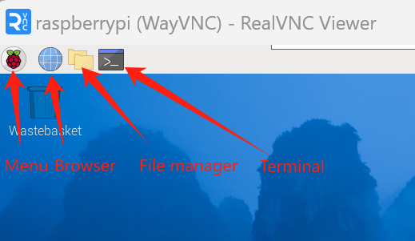

When you click the Terminal icon, following interface appears.

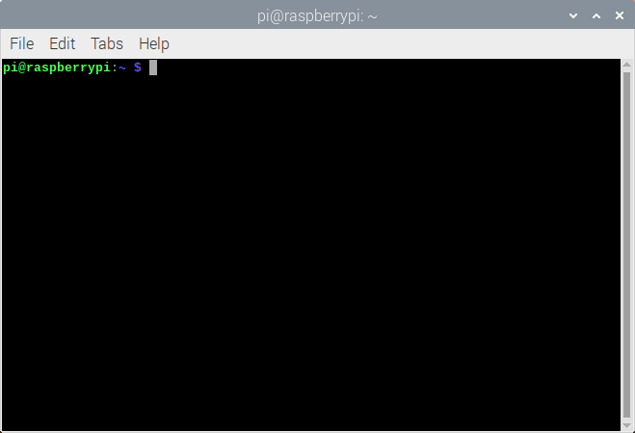

###### Note: The Linux is case sensitive.

First, type “ls” into the Terminal and press the “Enter” key. The result is shown below:

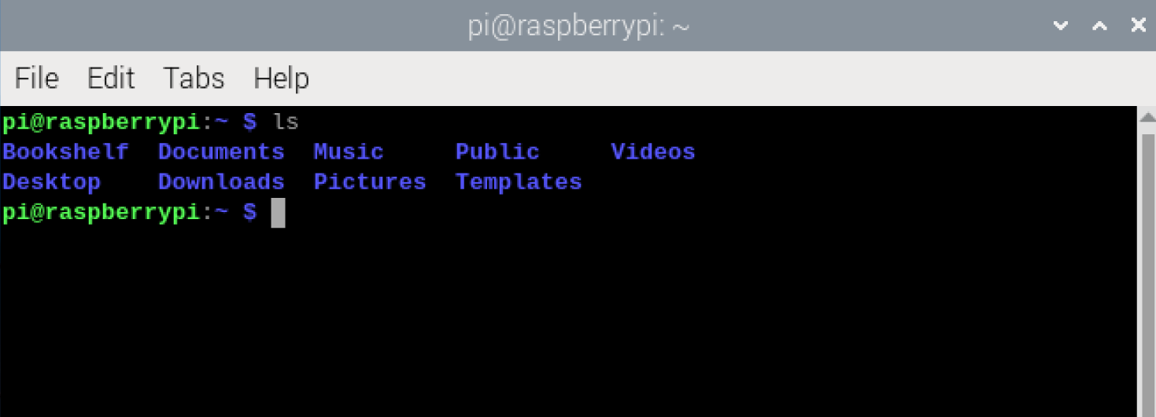

The ”ls” command lists information about the files (the current directory by default).

Content between “$” and ”pi@raspberrypi:” is the current working path. “~” represents the user directory, which refers to “/home/pi” here.



“cd” is used to change directory. “/” represents the root directory.

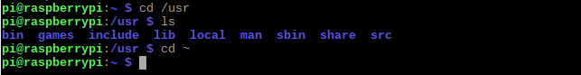

Later in this Tutorial, we will often change the working path. Typing commands under the wrong directory may cause errors and break the execution of further commands.

Many frequently used commands and instructions can be found in the following reference table.

|  |  |
| --- | --- |
| **Command** | **instruction** |
| **ls** | Lists information about the FILEs (the current directory by default) and entries  alphabetically. |
| **cd** | Changes directory |
| **sudo + cmd** | Executes cmd under root authority |
| **./** | Under current directory |
| **gcc** | GNU Compiler Collection |
| **git clone URL** | Use git tool to clone the contents of specified repository, and URL in the repository address. |

There are many commands, which will come later. For more details about commands. You can refer to: [http://www.linux-commands-examples.com](http://www.linux-commands-examples.com/)

## 5.2 Shortcut Key

Now, we will introduce several commonly used shortcuts that are very useful in Terminal.

1. **Up and Down Arrow Keys**: Pressing “↑” (the Up key) will go backwards through the command history and pressing “↓” (the Down Key) will go forwards through the command history.
2. **Tab Key**: The Tab key can automatically complete the command/path you want to type. When there is only one eligible option, the command/path will be completely typed as soon as you press the Tab key even you only type one character of the command/path.

As shown below, under the '~' directory, you enter the Documents directory with the “cd” command. After typing “cd D”, pressing the Tab key (there is no response), pressing the Tab key again then all the files/folders that begin with “D” will be listed. Continue to type the letters "oc" and then pressing the Tab key, the “Documents” is typed automatically.

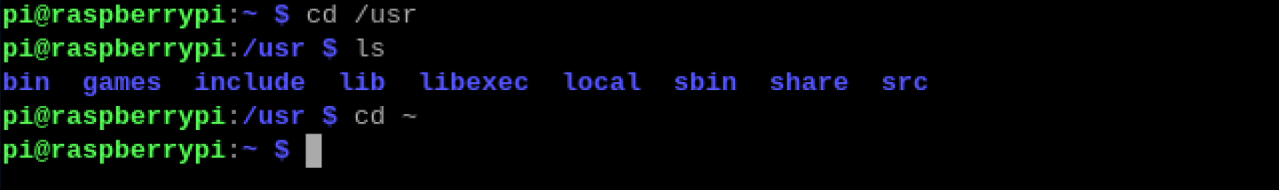

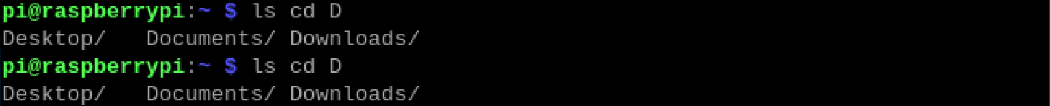

## 5.3 Install WiringPi

WiringPi is a GPIO access library written in C language for the used in the Raspberry Pi.

WiringPi Installation Steps

To install the WiringPi library, please open the Terminal and then follow the steps and commands below. Note: For a command containing many lines, execute them one line at a time.

Enter the following commands **one by one** in the “terminal” to install WiringPi:

sudo apt-get update

git clone <https://github.com/WiringPi/WiringPi> cd WiringPi

./build



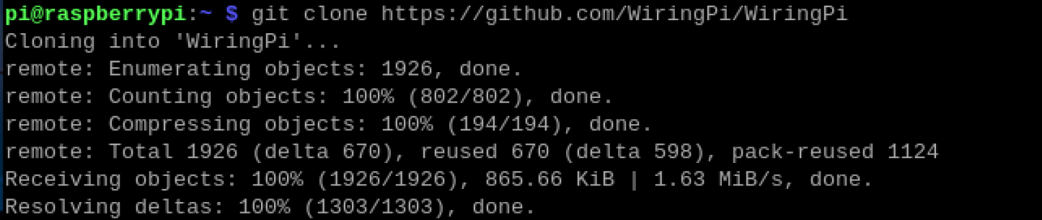

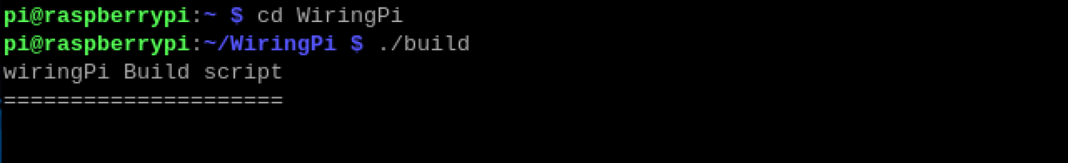

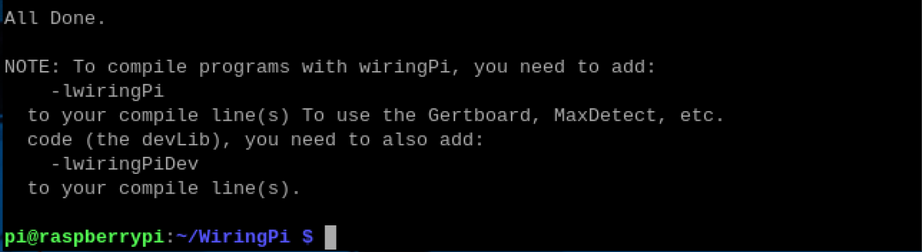

Run the gpio command to check the installation:

gpio -v

Input the “gpio -v” command,if there show the gpio version,it indicate that the installation is successed.

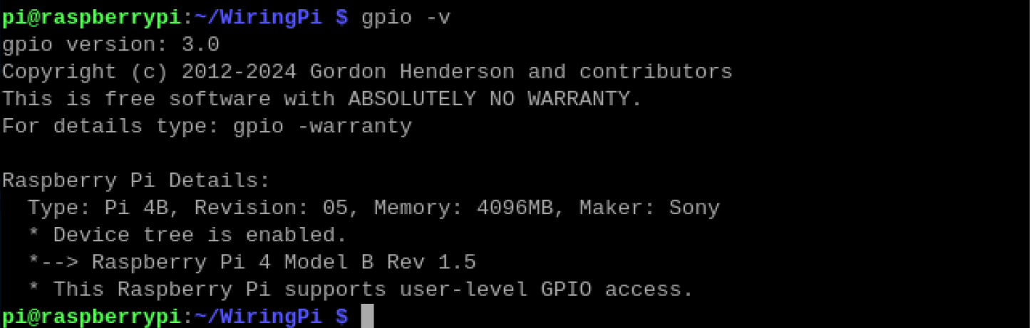

## 5.4 Obtain the Project Code

After the above installation is completed, you can visit our GitHub resources at [(](https://github.com/freenove)**[https://github.com/cokoino](https://github.com/freenove)**) to download the latest available project code. We provide **Python** language code for this project .

This is the method for obtaining the code:

In the pi directory of the RPi terminal, enter the following command.

cd

git clone --depth 1 https://github.com/cokoino/ckk0011

###### (There is no need for a password. If you get some errors, please check your commands.)

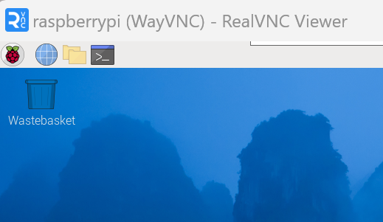

After the download is completed, a new folder "ckk0011" is generated, which contains all of the tutorials and required code.

Click File manager,you will find the folder "ckk0011"

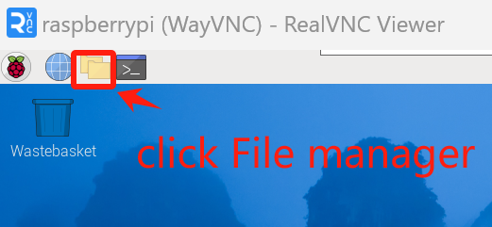

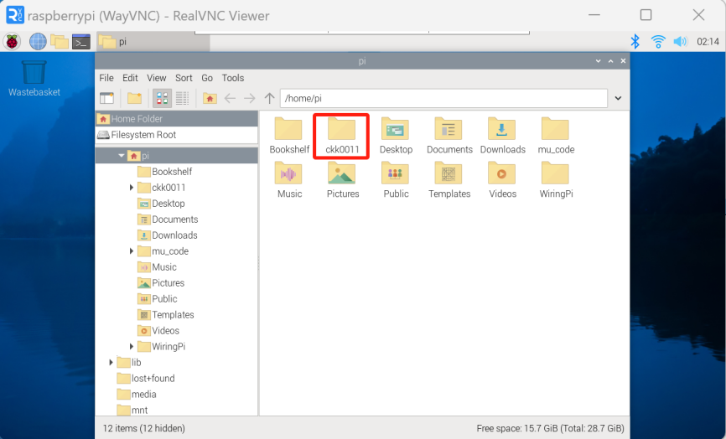

If you have no experience with Python, we suggest that you refer to this website for basic information and knowledge.

<https://python.swaroopch.com/basics.html>

# 6.Python2 & Python3

If you only use C/C++, you can skip this section.

Python code, used in our kits, can now run on Python2 and Python3. Python3 is recommend. If you want to use Python2, please make sure your Python version is 2.7 or above. Python2 and Python3 are not fully compatible. However, Python2.6 and Python2.7 are transitional versions to python3, therefore you can also use Python2.6 and 2.7 to execute some Python3 code.

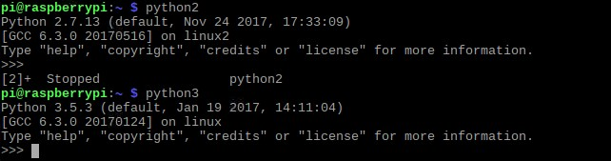You can type “python2” or “python3” respectively into Terminal to check if python has been installed. Press Ctrl-Z to exit.

Type “python”, and Terminal shows that it links to python2.

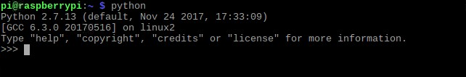

If you want to use Python3 in Raspberry Pi, it is recommended to set python3 as default Python by following the steps below.

Enter directory /usr/bin

cd /usr/bin

1. Delete the old python link.

sudo rm python

1. Create new python links to python3.

sudo ln -s python3 python

1. Execute python to check whether the link succeeds.

python

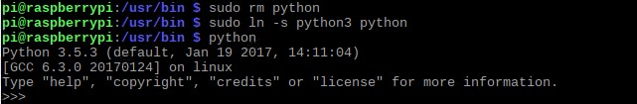

If you want to use Python2, repeat the steps above and just change the third command to the following:

sudo ln -s python2 python

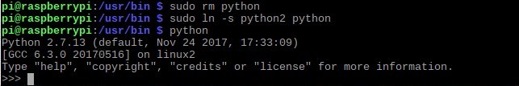

We will only use the term “Python” without reference to Python2 or Python3. You can choose to use either. Finally, all the necessary preparations have been completed! Next, we will combine the RPi and electronic components to build a series of projects from easy to the more challenging and difficult as we focus on learning the associated knowledge of each electronic circuit.